

**R Lab Handbook**

**Module coordinator:** Dr Camilo Calderon

**Email:** cam.calderon@dmu.ac.uk

**This version: 03/07/2025**

This handbook has been produced to provide students with specific information and guidance about their labs. The contents of this handbook are indicative, this means they can be updated or modified upon the review of the module leader (Cam).

An electronic version of this handbook (which is continuously updated) is available on the VLE system, Blackboard, which you should consult regularly as the main reference point throughout your studies.

Indicative Contents

Lecture 1 – Video: Introduction, Module, Assessment 4

Lecture 2 – Approaching Forecasting & Data Collection 5

Lecture 3: Videos about R (Linked with MCQs assessment) 6

**Prerequisite** – A Quick Intro to R 7

Lab 1 – R certification & Package swirl 16

Lab 2 – Uploading Excel Files to R 25

Lab 3 – Data Visualisation 29

Lab4 Mock/Practice test & AI AND R 34

Lab 5 – Intro to Refinitiv 37

Lab 6 – Refinitiv :News, forecasts, Macrox 49

Lab 1 – Introduction and Assessment

# Introduction



# Assessment

**Faculty of Business and Law**

**Assignment Brief**

|  |  |  |  |
| --- | --- | --- | --- |
| **Module Title** | Econometrics & Data Analytics | **Assignment Number** | 2 |
| **Module Code** | BECS2002 | **Assignment Title** | Portfolio |
| **Module Leader** | Dr Cam Calderon | **Assignment Weighting** | 40% |
|  |  |  |  |
| **Assignment Release Date:** | **XXXXX** |  |  |
| **Submission Date/Time:** | **XXXXX** |  |  |

|  |
| --- |
| **Assessment Information – What you need to do** |
| This assignment is an individual assignment.  Students must record a presentation about commodity forecasting. The commodities for this assessment are reviewed in the ‘Assessment Details’ section of this brief.  Research, analysis, communication, time management, organisational skills will all be fundamental skills required in this assignment. You must manage all aspects of this task yourself; however, if you have questions on this assignment, you must contact your Module Leader (Cam Calderon) at the first available opportunity. |

|  |
| --- |
| **Criteria for Assessment - How you will be marked** |
| Effective introduction 10%  Key literature, citations, and referencing 10%  Appropriate use of Refinitiv software 10%  Appropriate use of RStudio software 10%  Subject knowledge of forecasting methods 20%  Recommendations, policy alternatives, and plans 20%  Appropriate Conclusions 10%  Professional presentation 10%   * An Effective Introduction means effective motivation, context, importance of the topic, main argument that the piece will support, purpose, roadmap, and professional tone. * Key literature, citations, and Referencing means the use of crucial literature about the topic relevant to forecasting, appropriate citation and reference list. Use a few essential academic papers. * Appropriate use of Refinitiv software means the use of the capabilities of the software to explain the topic of presentation. * Appropriate use of RStudio software means self-forecasting outputs such as tables and figures. The R code must be pasted at the very end of the slides. **Paste the R code at the end of your slides.** * Subject knowledge of forecasting methods means the use of out-of-sample forecasting method and the use of forecasting techniques covered in the module. Students must apply the highest number of forecasting techniques covered in the module. * Recommendations, policy alternatives, plans means your best forecast and findings must help different stakeholders linked to the topic of the presentation. * Appropriate conclusions means effective summary of main points, reiteration of the findings, implications, call to action, final reflections, and future directions of the topic. * Professional presentation means well-prepared and engaging speech, clarity and quality of visual elements, quality of the slides.   Further information on University mark descriptors can be found here.  Learning Objectives   1. Critically analyse the knowledge of the methodology of economics and business and the quantitative links of both theory and application, including alternative approaches. (Portfolio and Presentation) 2. Develop proficiency in a variety of econometric and forecasting techniques and expertise in applying these techniques to a variety of explanatory or predictive problems in economics (macro and micro). (Portfolio and Presentation) 3. Articulate and synthesise competent knowledge of a variety of econometric and forecasting methods both verbally, graphically and in written form, working with diverse types of variables and data structures. (Portfolio and Presentation) 4. Apply knowledge to a range of specialised areas within economics or linked to economics, engaging with latest research developments and development of technical skills in statistical software and database software(s). (Portfolio and Presentation) |

|  |
| --- |
| **Assessment Details**  Record a 10 to 15-minute presentation and submit via Turnitin. Use online tools to reduce the size of your file if needed.  Students must record one individual video with their face, voice, and slides and submit the recording via Turnitin. Students can create their videos using Panopto at: Panopto.dmu.ac.uk. after signing in with their p-number and password; students can record a video by clicking on “+ Create.” Alternatively, there are many freely available software, such as FFSPLIT or CamStudio, to record presentations. One option is to use PowerPoint capabilities to record and publish presentations, https://support.office.com/en-gb/article/record-a-slide-show-with-narration-and-slide-timings-0b9502c6-5f6c-40ae-b1e7-e47d8741161c.  Internal moderators and External Examiners will be allowed to review the video clips via Learning Zone and/or through SharePoint.  Electronic Access  This brief is available electronically on LZ. If you would like it issued to you in a different print format, please contact Cam.  PRESENTATION TOPICS  Choose only ONE of the following topics.  Topic 1: Gold  Topic 2: Copper  Topic 3: 2-Year Treasury Bond  Topic 4: Oil  Topic 5: Wheat |

|  |
| --- |
| **How to Submit Your Assessment**  The assessment must be submitted by **12:00 noon (GMT/BST) on XXXXX**. No paper copies are required. You can access the submission link through the module web.   * Your coursework will be given a zero mark if you do not submit a copy through Turnitin. Please take care to ensure that you have fully submitted your work. * Please ensure that you have submitted your work using the correct file format, unreadable files will receive a mark of zero. The Faculty accepts Microsoft Office and PDF documents, unless otherwise advised by the module leader. * All work submitted after the submission deadline without a valid and approved reason will be subject to the [University regulations](https://www.dmu.ac.uk/about-dmu/quality-management-and-policy/academic-quality/academic-regulations-assessment-boards/academic-regs-assessment-board-homepage.aspx) on late submissions.   + If an assessment is submitted up to 24 hours late the mark for the work will be capped at the pass mark of 40 per cent for undergraduate modules or 50 per cent for postgraduate modules   + If an assessment is submitted beyond 24 hours late the work will receive a mark of zero per cent   + The above applies to a student’s first attempt at the assessment. If work submitted as a reassessment of a previously failed assessment task is submitted later than the deadline the work will immediately be given a mark of zero per cent   + If an assessment which is marked as pass/fail rather than given a percentage mark is submitted later than the deadline, the work will immediately be marked as a fail * The University wants you to do your best. However, we know that sometimes events happen which mean that you can’t submit your coursework by the deadline – these events should be beyond your control and not easy to predict.  If this happens, you can apply for an extension to your deadline for up to five working days, or if you need longer, you can apply for a deferral, which takes you to the next assessment period (for example, to the re-sit period following the main Assessment Boards). You must apply before the deadline for your assessment. You will find information about applying for [extensions and deferrals here.](https://www.dmu.ac.uk/current-students/student-support/exams-deferrals-regulations-policies/index.aspx) * Students MUST keep a copy and/or an electronic file of their assignment. * Checks will be made on your work using anti-plagiarism software and approved plagiarism checking websites. |

|  |
| --- |
| **Return of Marked Work**  You can expect to have feedback returned to you on 9th February 2024 (15 working days). If for any reason there is a delay, you will be kept informed. Marks and feedback will be provided online via Turnitin. It is important that you access the feedback you receive as this will help to make improvements to your later work, you can request a meeting with your Module Leader or Personal Tutor to discuss your feedback in more detail.  Marks will have been internally moderated only, and will therefore be provisional; your mark will be formally agreed later in the year once the external examiner has completed their review. More information on assessment and feedback [can be found here](https://www.dmu.ac.uk/about-dmu/quality-management-and-policy/academic-quality/learning-teaching-assessment/assessment-feedback-policy.aspx). |

|  |
| --- |
| **Academic Integrity and Generative AI Use**  In submitting a piece of work for assessment it is essential that you understand the University's requirements for maintaining academic integrity and ensure that the work does not contravene University regulations. Some examples of behaviour that would not be considered acceptable include plagiarism, re-use of previously assessed work, collusion with others and purchasing your assignment from a third party. For more information on academic offences, bad academic practice, and academic penalties, please read [chapter four of our academic regulations](https://www.dmu.ac.uk/current-students/student-support/exams-deferrals-regulations-policies/student-regulations-and-policies/index.aspx).  **Generative AI tools cannot be used for this assessment.** You must not use generative artificial intelligence (AI) to generate any materials or content in relation to your assessment. The only one exception is the use of AI to help the creation of the R script.  **Any use of generative AI needs to be appropriately acknowledged. Students should add a statement explaining which technologies were used, how they were used and how this output was then used to complete the assignment. Direct use of outputs should be cited.**  **Examples of a student acknowledgement statement are shown below:**  *Statement of acknowledgment 1 - generative AI used when module leader allows it.*  I have used (*list all AI system (s) used and links* e.g., Google’s Bard, <https://bard.google.com>) to (*provide details of how you have used generative artificial intelligence* e.g., to breakdown some of the concepts taught on the module). The prompt (s) I have used are (*include the prompt (s)*e.g., you are an enthusiastic tutor who is also an experienced economist, help me understand the concept of game theory with explanations and examples). What was generated from these prompts was used to (*explain how they were used in your submission*, e.g., develop a section on game theory exemplars).  *Statement of acknowledgment 2 – generative AI not used when module leader allows it.*  This assessment has not used any generative-AI.  You can find the library guide on generative AI use here - <https://library.dmu.ac.uk/genai> |

|  |
| --- |
| **Academic Support and Your Well-being**  Referencing is the process of acknowledging other people’s work when you have used it in your assignment or research. It allows the reader to locate your source material as quickly and easily as possible so that they can read these sources themselves and verify the validity of your arguments. Referencing provides the link between what you write and the evidence on which it is based.  You identify the sources that you have used by citing them in the text of your assignment (called **citations** or **in-text citations**) and referencing them at the end of your assignment (called the **reference list** or **end-text citations**). The reference list only includes the sources cited in your text. The main referencing guide can be [found here](https://library.dmu.ac.uk/refguide/home) and includes information on the basics of referencing and achieving [good academic practice](https://library.dmu.ac.uk/navlss/academic-practice). It also has tabs for the specific referencing styles depending on whether you require [Harvard style used in business](https://library.dmu.ac.uk/refguide/harvard) or [OSCOLA style used by the Law school.](https://library.dmu.ac.uk/law/referencing)  The University has a wealth of support services available to students; further information can be obtained from [Student Gateway](https://www.dmu.ac.uk/current-students/student-support/index.aspx), the [Student Advice Centre](mailto:studentadvicecentre@dmu.ac.uk?subject=Request%20for%20Support), [Library and Learning Services](https://library.dmu.ac.uk/DMU) and, most importantly, your Personal Tutor. If you are struggling with your assessments and/or deadlines please do seek help as soon as possible so that appropriate support and guidance can be identiﬁed and put in place for you. More information can be found on the [Healthy DMU pages](https://www.dmu.ac.uk/healthy/index.aspx). |

Lecture 2 – Approaching Forecasting & Data Collection

Slide 1



Slide 2



Lecture 3: Videos about R (Linked with MCQs assessment)

🎥 EP1 Simple Linear Regression / R RStudio 📊 Beginners 🐣

<https://youtu.be/M1FhKtJoFhw>

🎥 EP2 Linear Regression Example: UK 👑 Rent & House Price Index / R RStudio 📊 Beginners 🐣

<https://youtu.be/M_6Aid13ewM>

🎥 EP3 Prediction 🧙‍♂️✨with Linear Regression 📈 / R R Studio 📊 Beginners

<https://youtu.be/HY2YISPFiJU>

🎥 EP4 Assessing Coefficients 📈, Repeated Sampling and Variance Estimation 📊

<https://youtu.be/oDjjElQsN30>

Lecture 4: Performance and Evaluation I

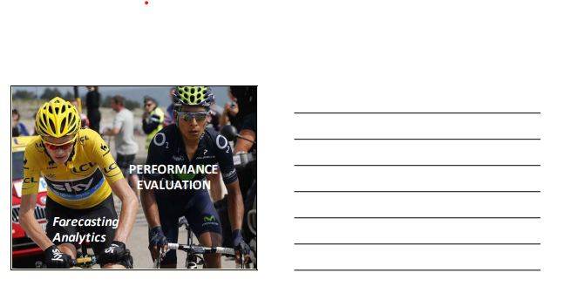

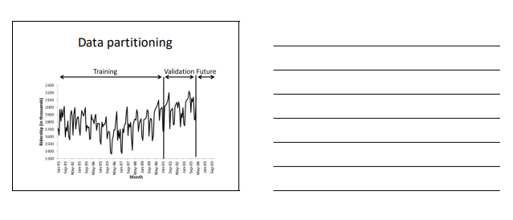

**Prerequisite** – A Quick intro to R

# 1. Install R and RStudio on your laptops/gadgets

# 2. Introduction to R

# 1. Install R and RStudio on your laptops/gadgets

# RStudio is a wrapper for R; we are using RStudio because it makes looks R more organised and straightforward

# Install R and R Studio on your laptops/gadgets

# Installing R

# [www.r-project.com](http://www.r-project.com)

# cran mirror - > <https://cran.r-project.org/mirrors.html>

# UK mirror -> <https://cran.ma.imperial.ac.uk/>

# download R for Windows

# download R for the first time -> <https://cran.ma.imperial.ac.uk/bin/windows/base/R-4.2.1-win.exe>

# double-click downloaded file ->Run -> language:English, click ‘OK’ -> Next -> Next -> Next -> Next -> Next -> Next : installing… -> Finish

# Installing RStudio

# rstudio.com

# click download - > <https://rstudio.com/products/rstudio/download/>

# download Free version:

# <https://rstudio.com/products/rstudio/download/#download>

# download RStudio for Windows

# Next -> Next -> Install

# Finish

# Introduction to R

# Long Tutorial

# <https://cran.r-project.org/doc/manuals/r-release/R-intro.pdf>

# Quick tutorial - RStudio Screen

# After installing R and RStudio, open Rstudio.

The **Environment** tab shows all the active objects (see next slide). The History tab shows a list of commands used so far.

The **Console** is where you can type commands and see the output

The **Files** tab shows all the files and folders in your default environment as if you were on a PC/Mac window. The **Plots** tab will show all your graphs. The **Packages** tab will list a series of packages or add-ons needed to run specific processes. For additional info see the **Help** tab

# Let's choose a better appeareance for our RStudio. Click on "Tools" and then "Global Options."

# Afterwards, in the window "Options", click on "Appearance", RStudio theme: "Modern", Editor font: "Courier", Editor theme: Cobalt. Finally, click on "Apply"

# Now, we want to open a file to save what we are going to learn during this session. Click on 'File', 'New File', and 'R Script'; or simply press Ctrl+Shift+N; this will open a new panel called 'Script' where we are going to write the commands for R. The name of the script is Untitled 1. At the end of this session save the script in a folder for this module.

# Let's learn how to write our own comments in our R code/ script. On the script panel, type the caracter # and then write 'LAB ONE – ECON2545 – AND THE DATE TODAY'. R will ignore any line of command starting with #. You can use # to add comments, titles, reminders within your R code/ R Script.

# 

# The usual Rstudio screen has four windows: 1. Console. 2. Environment and history. 3. Files, plots, packages and help. 4. The R script(s) and data view. The R script is where you keep a record of your work. For Stata users this would be like the do-file, for SPSS users is like the syntax and for SAS users the SAS program.

# Let's type 'getwd()' in line number 2 and hit the keys' ctrl' and 'enter' in your keyboard at the same time. If you did this correctly you will see in the console panel the folder that R is using to download and upload data.

# Let's create a folder in Windows for your course using File Explorer. I called my folder 'R code – LABs'. Afterwards, in RStudio' go to 'Session', 'Set Working Directory', and 'Choose Directory', afterwards, select the folder 'R code – LABs' or the name you used.

# 

# The above will result in code within the console, the code is setwd(and a path/directory to the folder in your computer). Copy and paste that in your R code; next time will only need to hit 'ctrl' and 'enter' to set the directory where you are going to work.

# Copy and paste the outcome of you console in your R code; next time you will only need to hit 'ctrl' and 'enter' to set working directory.

# In line number 4, type 5*5 and hit 'ctrl' and 'enter', the console will show the code and the result, 25.

# Let's create a matrix; use the lines 5 and 6 in your script and hit 'ctrl' & 'enter' to line 5 and then 6.

# If you did it correctly, the outcome in the console will be as follows:

# In the line 5, you asked R to create a matrix called 'A', with numbers from 1 to 8, with four rows and two columns.

# Have a look at the 'Environment' panel, you can see in there all active objects(e.g. matrix A), and the panel 'History' shows a list of commands used do far.

# To see the matrix A in a new window, type the command View(A) in line 7 and hit the keys' ctrl’&’enter' to run line 7. Afterwards, come back to your R script 'Untitled 1'.

## Packages tab

# The package tab shows the list of add-ons included in the installation of RStudio. If checked, the package is loaded into R, if not, any command related to that package won't work, you will need select it. You can also install other add-ons by clicking on the 'Install Packages' icon.

# Another way to install add-ons is to type the command install.packages("name of the package"), and then you will be able to open the library of commands of that package.

# In line 8, to install the package forecast, type install.packages(“forecast”) and hit ctrl+enter. In the next window, you can hit yes to restart RStudio. See the picture below, you shall not get errors in the console, and at the end, the sign '>' will let you know the instalation run OK.

# You must activate the package by typing, for example, library(forecast). This will automatically check the 'forecast' package.

# We will use the package forecast in this course to analyse and predict economic time series.

# Do not forget to save your R script in your own course folder! Use the icon to save, I called my file "lab001" and now is available [by clicking on here](https://demontfortuniversity-my.sharepoint.com/:f:/g/personal/ccalde00_dmu_ac_uk/EsTN7n38ZG1CoTdjdcU51sYBZ5CAGAdhDDG-NfxVDz6fQA?e=NjJSal), folder 'R code – LABs'

Lab 1 – R certification & Package swirl

**Access LinkedIn Learning – First time logging in**

**\***Adapted from the library resources

1. Open any web browser and navigate to <https://www.linkedin.com/learning/login>

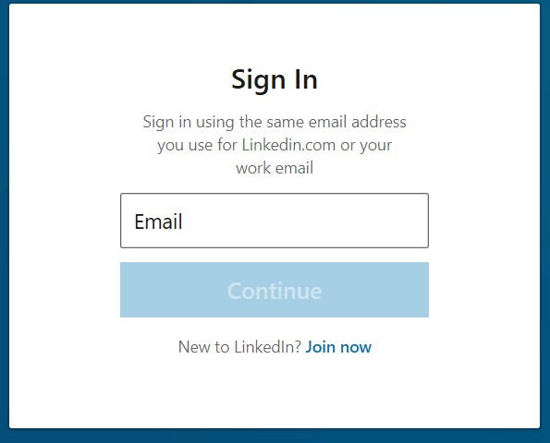  
*Figure 1 Sign in Screen*

1. Enter your DMU email address:

For students – your login credentials will be your DMU email address in the format Pnumber@my365.dmu.ac.uk

For DMU staff this is your Outlook full email address.

**Select Continue**

1. Select the 'Sign in with Single Sign On' blue button.

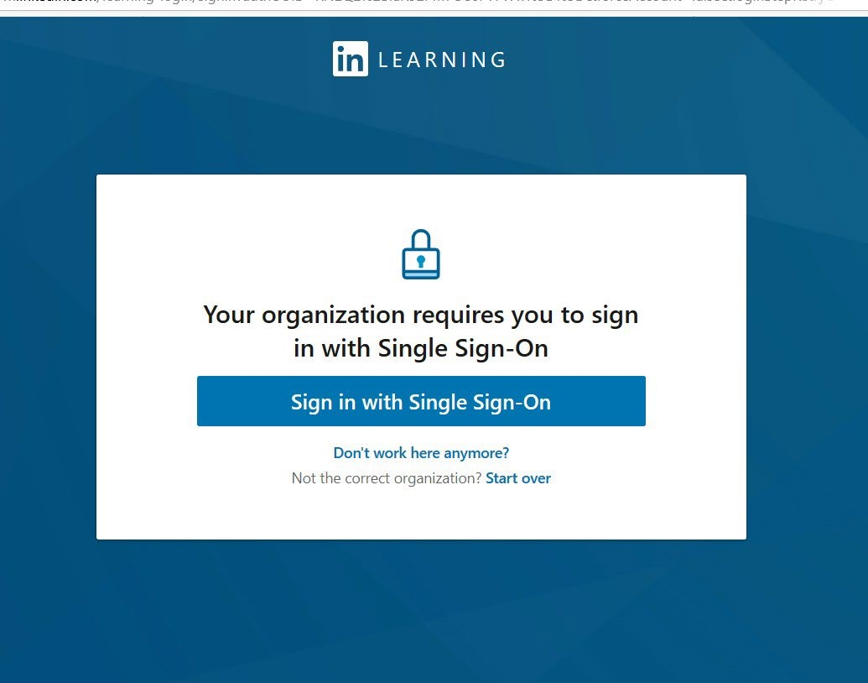 *Figure 1 Sign in Screen*

1. You will be taken to DMU's Single Sign in screen. Sign in with your login details.

**DMU Students**:

Username: Pnumber,

Password: <your password>

(Same login details that you use for MyDMU or LearningZone)

**DMU Staff:** Username/Password – same for Single-sign.

(Same login details that you use for Staff Portal or LearningZone

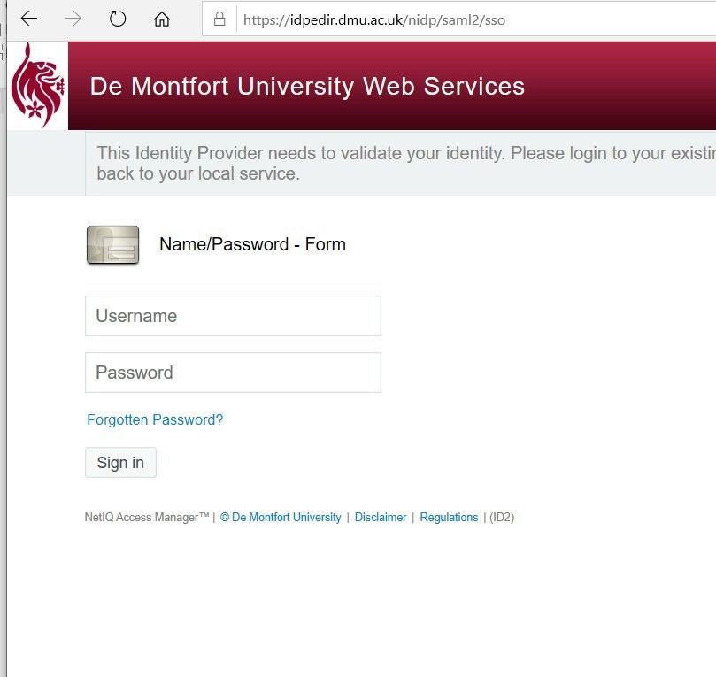 *Figure 3 DMU's Single Sign On Screen*

1. You will be presented with a LinkedIn learnings welcome screen.

You are given two options, select the one that applies:

1. If you do have an existing LinkedIn profile account you can select '**Connect my LinkedIn account**.
2. OR select the option '**Continue without LinkedIn**'.

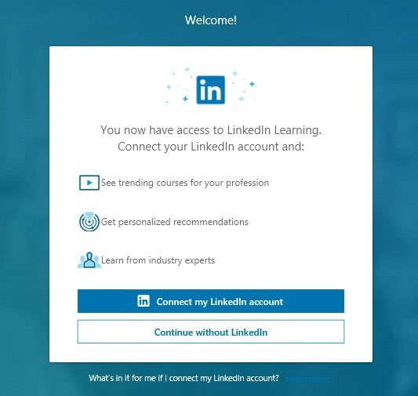

*Figure 4 Option to connect LinkedIn Account*

If you selected '**Continue without LinkedIn'**, you will be prompted to ensure you don't want to connect with LinkedIn - a social professional network – which allows you to build your professional profile and connect with other professionals.

Select the option '**Don’t connect my account’**.

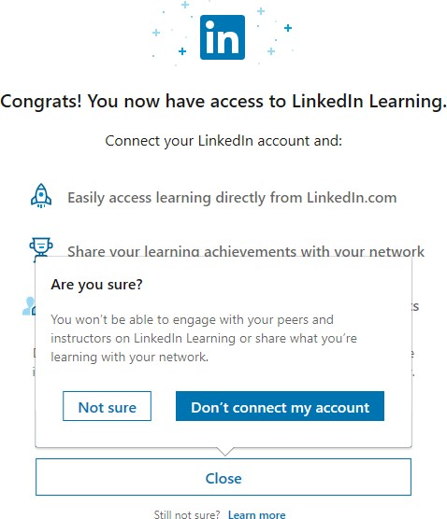

*Figure 5 Confirm connecting to LinkedIn Learning account*

1. Next you will be prompted to further personalise your learning experience. This can be helpful so that relevant content is accessible to you. Note that you can always add further course, skills from LinkedIn Learnings home page. **Select the ‘Sounds good’ blue button**.

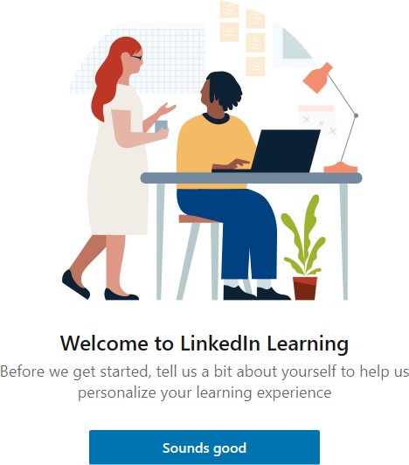

*Figure 6 Welcome to LinkedIn Learning*

1. 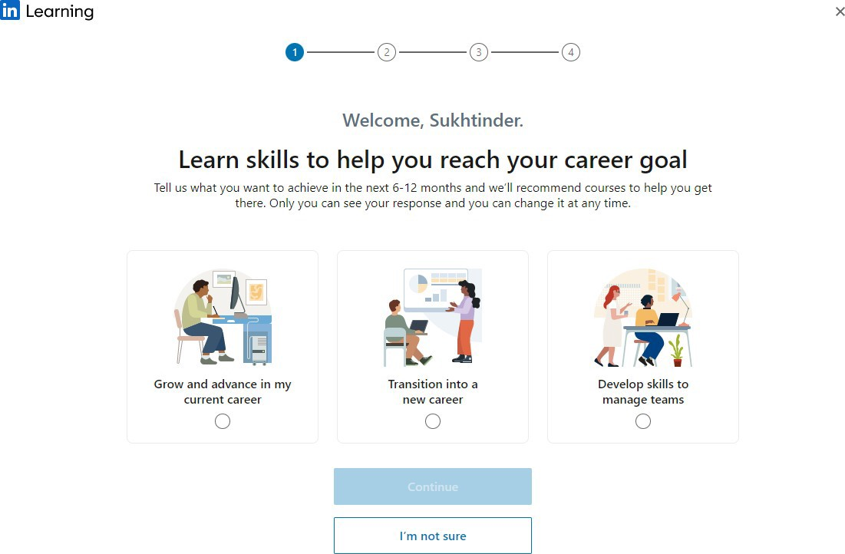You will be offered pathways to set skill targets (see Figure 7 Set Goals Screen below). You can don’t need to set these now and can come back to these later if you wish. **Select ‘I’m not sure’**.

*Figure 7 Set Goals Screen*

1. 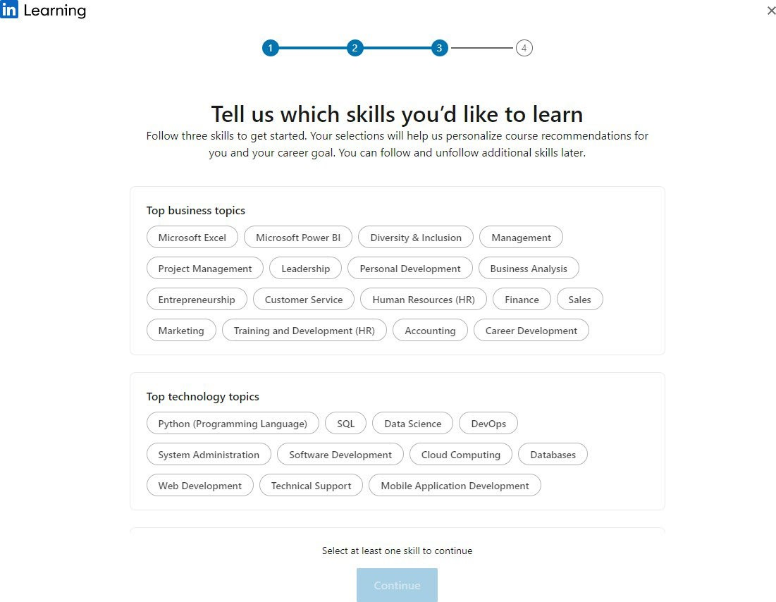Choose at least three skills by selecting any of the categories (as a minimum you should select at least three, you can always add more later). Once selected, **select the ‘Continue’ button**.

*Figure 8 Set some Skills*

1. 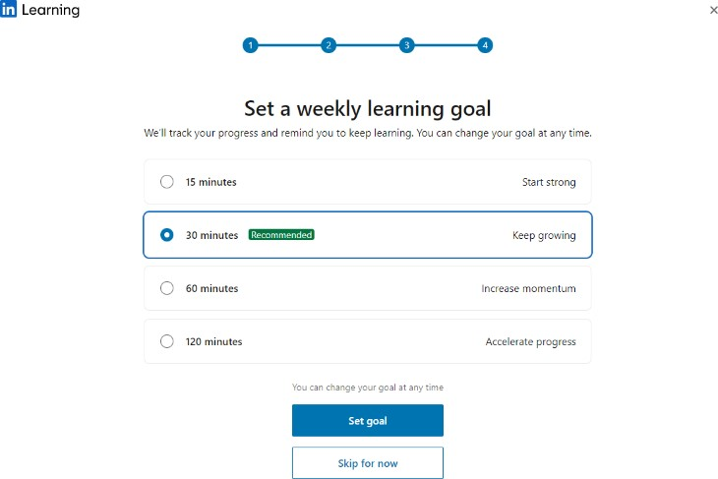You can set weekly viewing goals if you wish. These allow you to prioritise your learning and set time aside for watching course videos and track your progress. Or you can choose to set this later by selecting ‘**Skip for now’**.

*Figure 9 Set Weekly Viewing Goals*

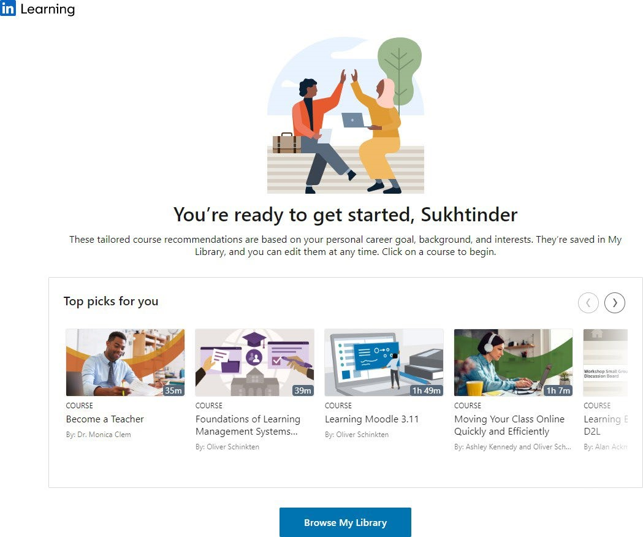**“You’re all set!”** You will be able to view some recommended courses and videos from LinkedIn Learning.

*Figure 10 Courses or Video Recommendations*

In your LinkedIn Learning personalised dashboard, the top main navigation bar will remain throughout as you watch video resources and resume videos when needed. The home icon appear will take you to your main LinkedIn Learning home page, where you can view recommended content, search resources.

**Now that your account is activated – just bookmark this direct URL link** **to login to LinkedIn Learning**<http://www.linkedin.com/learning/login>

To find out more about using LinkedIn Learning, please refer to the [LinkedIn Learning guide](https://library.dmu.ac.uk/linkedin) and the help provided.

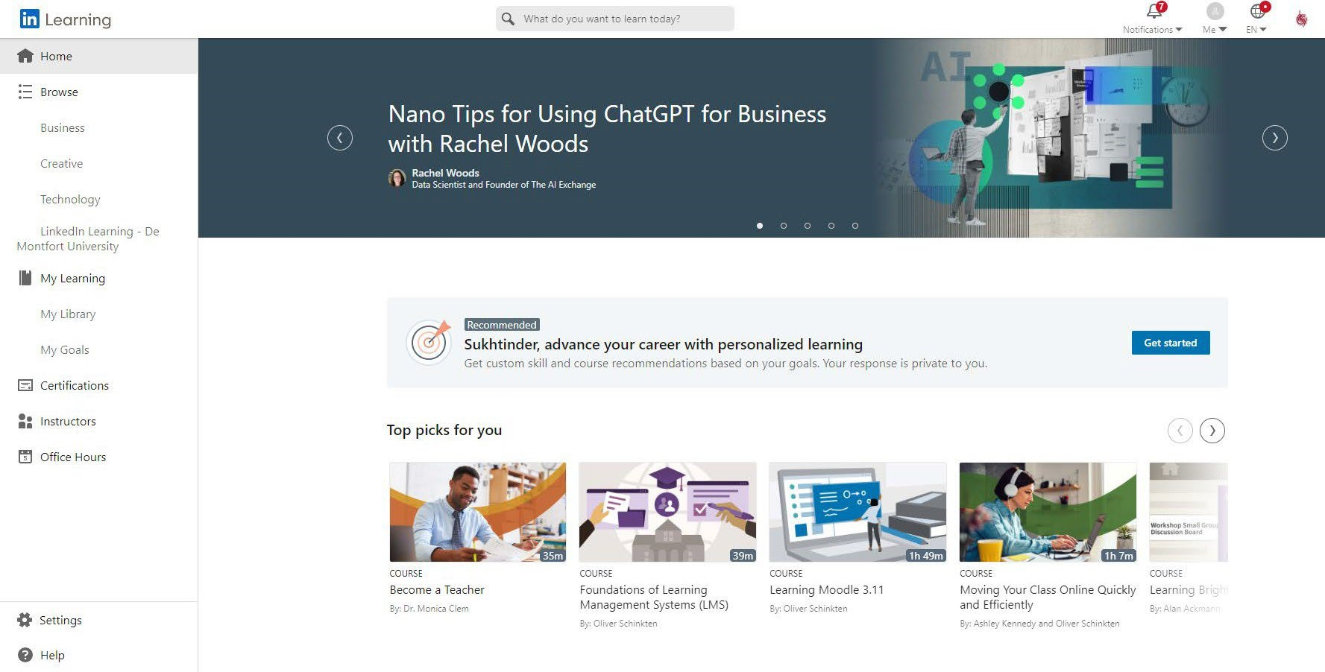

13 Best + Free R Programming Certification, Tutorial, Course and Training Online [2023 SEPTEMBER][UPDATED]

### [****Free Course Trial – R Programming Certification by Johns Hopkins University (Coursera)****](https://coursera.pxf.io/c/397676/1213622/14726?subId1=ddrprogrammingjhu&u=https%3A%2F%2Fwww.coursera.org%2Flearn%2Fr-programming)

### [Data Science: R Basics Certificate by Harvard University (edX)](https://www.edx.org/course/data-science-r-basics)

### [Free Course Trial – Statistics with R Certification by Duke University (Coursera)](https://coursera.pxf.io/c/397676/1213622/14726?subId1=ddrprogrammingstatistics&u=https%3A%2F%2Fwww.coursera.org%2Fspecializations%2Fstatistics)

### [Free Course Trial – Software Development in R Certification by Johns Hopkins University (Coursera)](https://coursera.pxf.io/c/397676/1213622/14726?subId1=ddrprogrammingswjhu&u=https%3A%2F%2Fwww.coursera.org%2Fspecializations%2Fr)

### [Programming for Data Science with R Nanodegree Certification (Udacity)](https://www.udacity.com/course/programming-for-data-science-nanodegree-with-R--nd118)

### [R Training Course Online (LinkedIn Learning)](https://www.linkedin.com/learning/learning-r)

### [R Programming Course A-Z™: R For Data Science With Real Exercises (Udemy)](https://click.linksynergy.com/deeplink?id=vedj0cWlu2Y&mid=47901&u1=ddrprog1&murl=https%3A%2F%2Fwww.udemy.com%2Fr-programming%2F)

### [****Data Science and Machine Learning Bootcamp with R (Udemy)****](https://www.udemy.com/course/data-science-and-machine-learning-bootcamp-with-r/)

### [****R Programming: Advanced Analytics In R For Data Science****](https://www.udemy.com/course/r-analytics/)

### [****Statistics with R – Beginner Level****](https://www.udemy.com/course/statistics-with-r-beginner-level/)

### [R Programming Courses & Tutorials Online (Pluralsight)](https://www.pluralsight.com/search?q=r%20programming)

### [R for Data Science Course (LinkedIn Learning)](https://www.linkedin.com/learning/r-for-data-science-lunchbreak-lessons)

## Script/Data View Window:

* Begin scripts with a comment for title and description using the hash character (#). Anything after the hash on the same line is considered a comment and is ignored by R.
* Code can continue to the next line without a special character, but only if the previous line ends in a way that suggests continuation (e.g., a comma or unclosed brackets).
* To run a line of code, position the cursor on the line and press Ctrl+Enter. For multiple lines, select them and press Ctrl+Enter.

## Console/Output Window:

* It's recommended to work in script mode for reusability.
* Commands outside the script context can be typed at the bottom of the console, indicated by the ">" sign.
* Press Enter to execute a command.
* Use the up and down arrows to revisit and edit older lines of code previously typed into the console.

# YOU MUST PUT A SCREENSHOT OF THE CERTIFICATION YOU RECEIVED ON THIS PAGE

# Package Swirl

‘swirl’ is an R package designed to teach you R programming and data science interactively. Here's a step-by-step guide on how to use swirl:

## Step 1: Install and Load the swirl Package

If you don't have the swirl package installed, you can install it using the following command:

install.packages("swirl")

Once installed, load the ‘swirl’ package with the following command:

library(swirl)

## Step 2: Start swirl and Follow the Prompts

To start swirl, enter the following command:

swirl()

After entering this command, you will be prompted to enter your name. Type your name and press enter.

## Step 3: Choose a Course

Next, you'll be prompted to choose a course. If this is your first time using swirl, you'll need to install a course. To install a course, type:

install_from_swirl("Course Name")

Replace "Course Name" with the name of the course you want to install. A list of available courses can be found on the swirl website.

You will need to install the R Programming course. Type:

install_from_swirl("R Programming")

After the course is installed, start swirl again:

swirl()

You will be prompted to select a course. Choose "R Programming" from the list.

## Step 4: Complete Lessons

You will now be prompted to select a lesson. Choose the first lesson and follow the instructions to complete it. The lesson will consist of interactive exercises that will introduce you to the basics of R programming.

As you progress, swirl will guide you through different lessons to gradually build up your R programming skills.

## Step 5: Progress Tracking

swirl keeps track of your progress. You can check your progress at any time by running:

swirl::progress()

This will show you which lessons you've completed and which ones you still need to work on.

And that's it! By following these steps, you'll be well on your way to learning R programming with swirl. Happy learning!

Lab 2 – Uploading Excel Files to R

# Introduction to R - uploading Data from Excel and CSV files

# Introduction to R making basic plots in R

# Introduction to R - uploading Data from Excel and CSV files

# Go to ONS.gov.uk

# Click on ‘data’ In the GDP quarter-on-quarter section.

# Click on Download full-time series as .xls

# Go to your folder ‘downloads’

# Rename the file as “gdp qoq”

# Save the file in your subfolder’ data’ on your folder “econ2545”. We created this folder during the previous lab.

# Open the excel file and set column names to ‘quarters’ and ‘gdp’ in columns A and B. Save the file.

# 

# Open Rstudio (do not open R) and click on ‘Import Dataset’, ‘from excel’, and choose the appropriate file on your folder ‘datasets’.

# 

# On the box ‘Skip’ type the number 7. We do not want to import rows 1 to 7.

# Copy the R code by clicking on the ‘copy’ icon.

# 

# Click on import.

# Go to your R script and paste (ctrl + v) the copied R code. You shall have the following code:

# 

# Plot the time series. Use the command plot.

# 

# Find the unemployment dataset in ONS, but this time download the full-time series as ‘.csv’ file, can you paste the appropriate code for csv files in your R script?

# Type ‘?plot’ and click on ‘Generic X-Y’ Plotting on the console to review more arguments you can use.

## Opening files from the book Principles of Econometrics with R

*This section is adapted from Hill, Griffiths, and Lim 2011

To open a data file for the Principles of Econometrics textbook, (Hill, Griffiths, and Lim 2011):

rm(list=ls()) # Caution: this clears the Environment

install.packages("devtools")

install.packages("remotes")

remotes::install_github("ccolonescu/PoEdata")

**library**(PoEdata)

**data**("andy") *# makes the dataset "andy" ready to use* ?andy *# shows information about the dataset*

*# Show head of dataset, with variables as column names:* **head**(andy)

*# Show a few rows in dataset:* **some**(andy)

## Creating Graphs in R

R provides a suite of functions to create and customize graphs. Here's a brief overview:

### Basic Plotting:

Function: plot()

Usage: To plot data points and lines.

Arguments:

x, y: Variables to be plotted.

xlab, ylab: Labels for x and y-axis.

type: Determines the style of the plot. Options include:

"p": Points only

"l": Lines only

"b": Both points and lines

"n": No plot, creates an empty graph. Useful as a foundation for other plot elements.

### Plotting Mathematical Curves:

Function: curve()

Usage: To plot a curve based on a mathematical function over a specified range.

Example:

**curve**(x^1, from=-2, to=2, xlab="x", ylab="y = x" ) *# Add another curve to the existing graph:*

**curve**(x^2, add = TRUE) *#plot(1:100, type='n')*

**curve**(**sqrt**(x), from=0, to=100, xlab="x", ylab="y")

Key Argument:

“add”: If set to TRUE, the curve is added to an existing graph.

### Adding Lines:

Function: abline()

Usage: To add lines defined by specific parameters to a graph.

Arguments:

a, b: Defines a line based on its intercept (a) and slope (b).

h: Specifies the y-value for drawing a horizontal line.

v: the x-value for drawing a vertical line. *x*-value for a vertical line; coef, the name of a simple linear regression object, which includes the intercept and slope of a regression line.

**plot**(1:10, type="n") *# creates an empty graph*

*# Add straight lines to graph:* **abline**(a=8, b=-0.5, h=3.5, v=4) **curve**(x^2, from=0, to=20) **abline**(v=10)

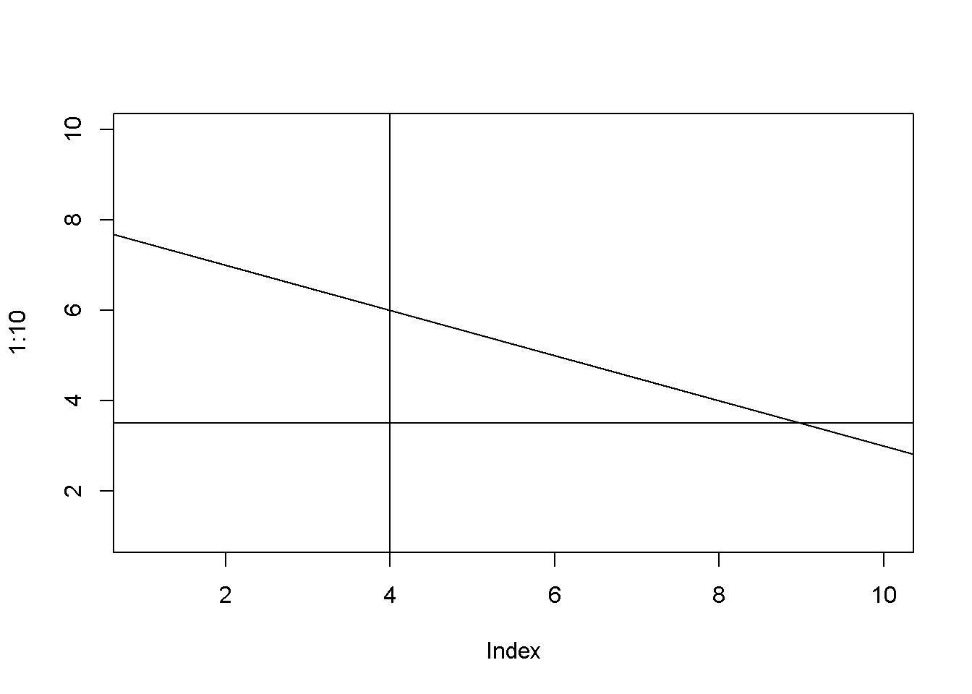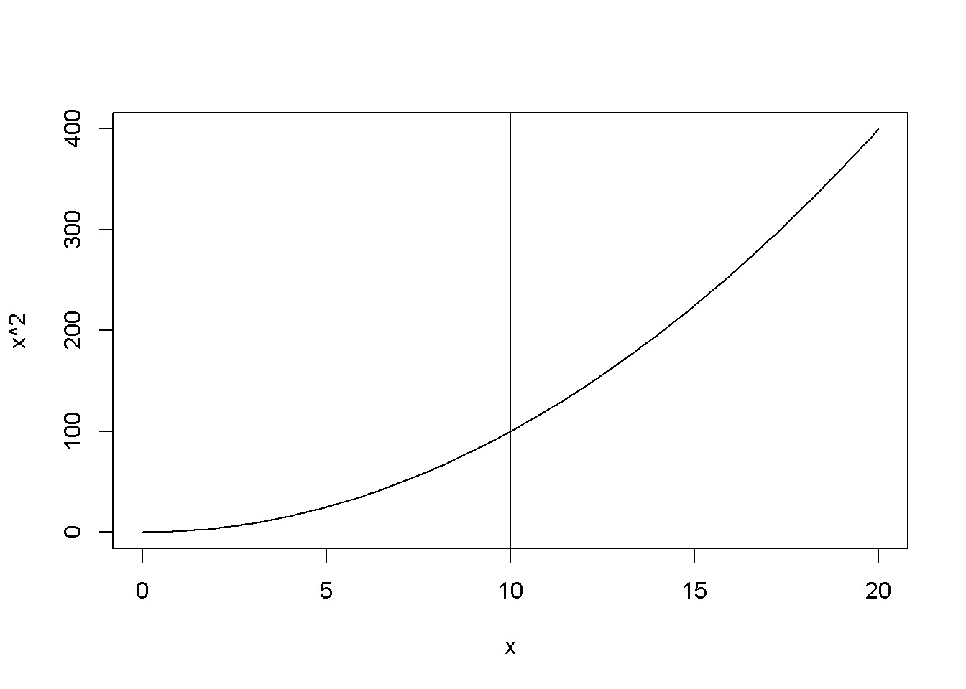

Examples of using the function ‘abline()‘

Lab 3 – Data Visualisation

Adapted from: [towardsdatascience.com/a-guide-to-data-visualisation-in-r-for-beginners-ef6d41a34174](https://towardsdatascience.com/a-guide-to-data-visualisation-in-r-for-beginners-ef6d41a34174)

Link to files: [course folder](https://demontfortuniversity-my.sharepoint.com/:f:/g/personal/ccalde00_dmu_ac_uk/EsTN7n38ZG1CoTdjdcU51sYBZ5CAGAdhDDG-NfxVDz6fQA?e=Ump35E)

# See the code below. Load the built-in dataset into R and type the following command in the console:

# data() #Explore the built-in datasets

# data(airquality)

# Data exploration:

# str(airquality) #It displays the internal structure of an R object

# Exploring the beginning of the data or the end of the data

# head(airquality, 7**)**

# tail(airquality,5)

# 

1. **Descriptive statistics**

summary(airquality)

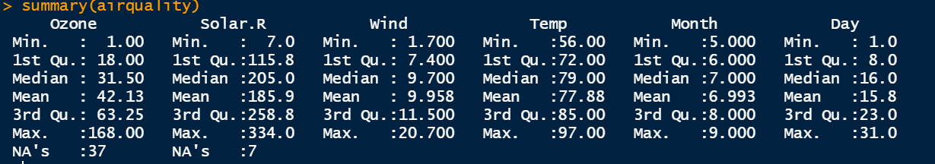

1. **Use the ‘Graphics’ package for plotting basic graphs**

library(help = "graphics")

1. **Plot the ozone column from airquality**

plot(airquality$Ozone)

1. **Plot a graph between ozone and wind to visualise a possible relation. Is there a negative correlation between ozone and air speed?**

plot(airquality$Ozone, airquality$Wind)

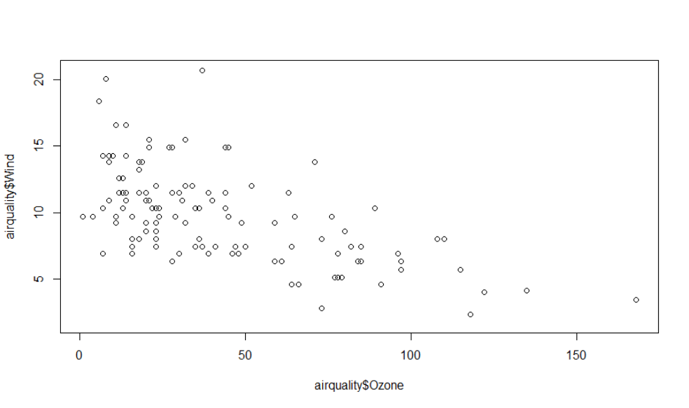

1. **Plot the entire dataset. Is there a positive correlation between temperature and ozone level?**

plot(airquality)

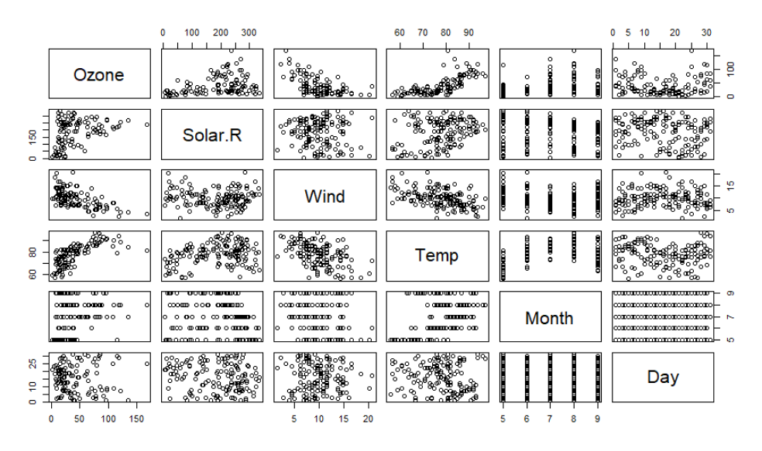

1. **points and lines**

plot(airquality$Ozone, type= "b")

**high density lines**

plot(airquality$Ozone, type= "h")

1. **type ?plot()**
2. **labels and titles**

plot(airquality$Ozone, xlab = 'ozone Concentration', ylab = 'No of Instances', main = 'Ozone levels in NY city', col = 'green')

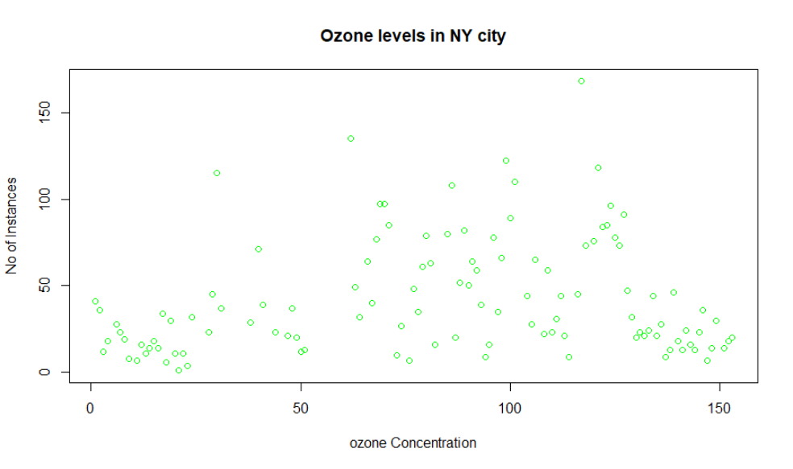

1. **horizontal bar plots**

barplot(airquality$Ozone, main = 'Ozone Concenteration in air',xlab = 'ozone levels', col= 'green',horiz = TRUE)

1. **vertical bar plots**

barplot(airquality$Ozone, main = 'Ozone Concenteration in air',xlab = 'ozone levels', col='red',horiz = FALSE)

1. **Create a histogram of the column solar radiation and explain the output.**

hist(airquality$Solar.R)

hist(airquality$Solar.R, main = 'Solar Radiation values in air',xlab = 'Solar rad.', col='red')

1. **Generate a boxplot of solar radiation. Explain the output.**

boxplot(airquality$Solar.R)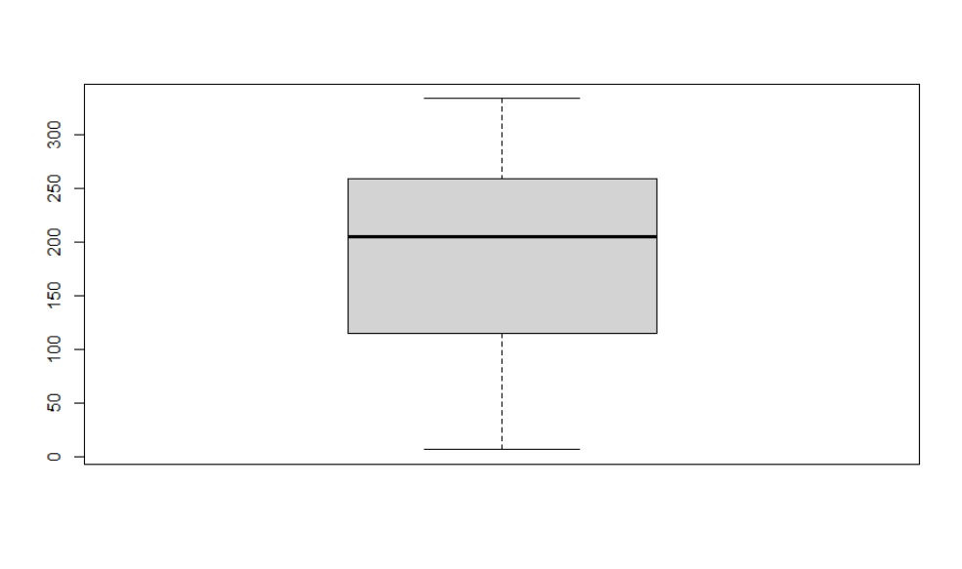

1. **Generate multiple box plots**

boxplot(airquality[,0:4], main='Multiple Box plots')

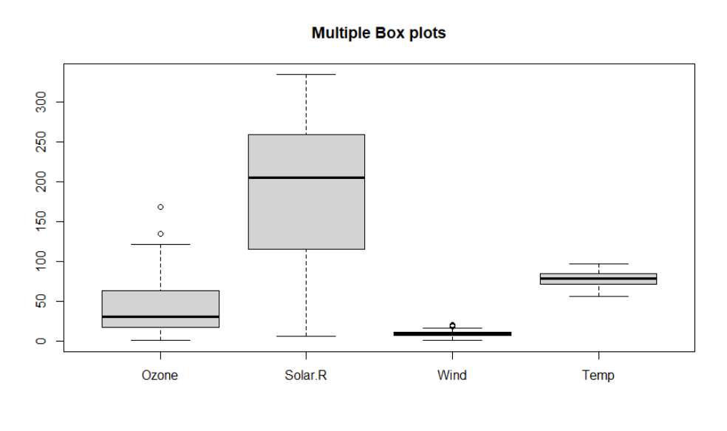

1. **Generate a grid charts**

par(mfrow=c(3,3), mar=c(2,5,2,1), las=1, bty="n")

plot(airquality$Ozone)

plot(airquality$Ozone, airquality$Wind)

plot(airquality$Ozone, type= "c")

plot(airquality$Ozone, type= "s")

plot(airquality$Ozone, type= "h")

barplot(airquality$Ozone, main = 'Ozone Concenteration in air',xlab = 'ozone levels', col='green',horiz = TRUE)

hist(airquality$Solar.R)

boxplot(airquality$Solar.R)

boxplot(airquality[,0:4], main='Multiple Box plots')

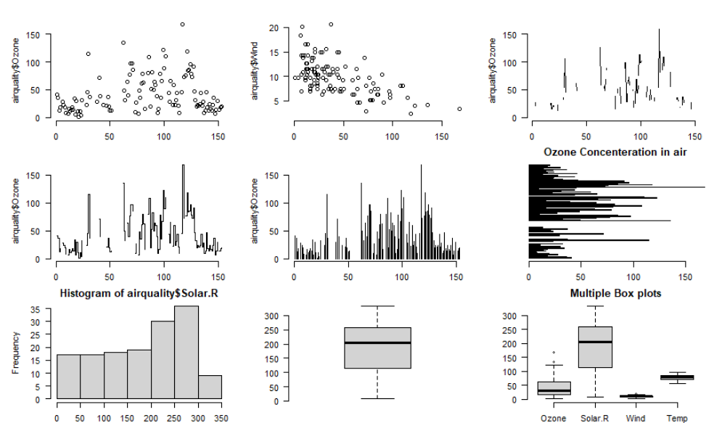

Other visualisation packages include lattice (good for kernel density plots) , ggplot2, plotty, maps (to plot country maps). Explore more on the link: <https://towardsdatascience.com/a-guide-to-data-visualisation-in-r-for-beginners-ef6d41a34174>

Lab 4 - Mock/Practice test & AI AND R

## MOCK/PRACTICE TEST

Go to the module site in the LZ. Go to the tile ‘Assessments’ and click on “Mock/Practice MCQs”. Students can take the test as many times they want. Each time, students will receive many new questions.

## Using ChatGPT to Write and Debug Simple R Scripts

### Introduction

This lab will guide students through the process of writing and debugging simple R scripts with the assistance of ChatGPT. Whether you're a beginner or an experienced R user, ChatGPT can provide valuable insights and help streamline your coding process.

### Prerequisites

* Basic understanding of R syntax and programming concepts.
* R and RStudio installed on your computer.

## Writing R Scripts with ChatGPT

### Step 1: Define Your Objective

Start by clearly stating what you want to achieve with your R script. For example:

"I want to calculate the mean of a numeric vector."

"I need to create a histogram of a dataset."

### Step 2: Ask ChatGPT for Code Snippets

Once your objective is clear, ask ChatGPT for a code snippet that accomplishes your task. For instance:

"Can you provide an R script to calculate the mean of a vector?"

"Show me how to create a histogram in R."

Ask ChatGPT: "Can you provide an R script to calculate the mean of a numeric vector?"

ChatGPT might provide a snippet like this:

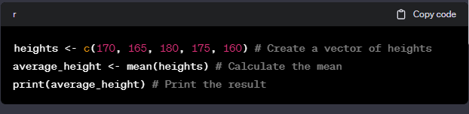

### Step 3: Analyze the Provided Code

ChatGPT will give you a code snippet. Read through it carefully and make sure you understand each part. You can ask ChatGPT to explain any lines or functions that are unclear.

### Step 4: Run the Code in RStudio

Copy the code snippet into RStudio (use an script) and run it. Observe the output to see if it meets your expectations.

## Debugging R Scripts with ChatGPT

### Step 1: Identify the Problem

If the code doesn't work as expected, identify the error message or the unexpected output. For example:

Error messages in the console.

Results that don’t match your expectations.

You run the script, but you receive an error: Error in mean(height): object 'height' not found.

### Step 2: Ask ChatGPT for Help

Describe the problem to ChatGPT. Be specific about the error or the issue. For example:

"I received an error message that says 'object not found'. What does this mean?"

"The histogram is not displaying any data. Can you help me fix it?"

"I tried to calculate the mean of a vector, but I got an error saying 'object not found'. Here's my code..."

### Step 3: Implement the Suggested Solutions

ChatGPT will suggest solutions or ask further questions to clarify the issue. Follow the suggestions step by step, adjusting your code as needed.

ChatGPT might respond with: "It looks like there's a typo in your code. The object you're trying to calculate the mean for is 'heights', not 'height'."

### Step 4: Test the Adjusted Code

After implementing the changes, rerun your script. If issues persist, describe the new output to ChatGPT, and continue the debugging process.

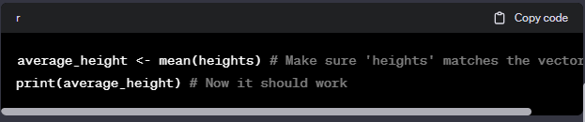

## Best Practices for Using ChatGPT with R

* Incremental Development: Write and test your code in small chunks to catch errors early.
* Clear Communication: When asking for help, provide clear and detailed information about your code and the issues you're facing.
* Understanding Over Copy-Pasting: Try to understand the code snippets provided rather than just copying and pasting them. This will improve your R programming skills over time.

## Conclusion

With the above steps, you can effectively use ChatGPT to write and debug simple R scripts. Remember, practice is key to becoming proficient in R, and using ChatGPT can accelerate your learning by providing instant assistance and feedback.

Additional Resources

[The R Manuals](https://cran.r-project.org/manuals.html)

[RStudio Cheatsheets](https://www.rstudio.com/resources/cheatsheets/)

Happy coding!

Lab 5 – Intro to Refinitiv

**Workshop – Introduction to Refinitiv Eikon**

Adapted from Darren Sparkes and Tom Webster’s ACFI3307

Complete the following activities to set up your Refinitiv Workspace account and learn the software's features.

**Activity 1.**

As a registered student on the ECON2545 module you should have received an email from Refinitiv that gives you your user ID (should be your DMU email address) and a link for you to access Refinitiv workspace as in Figure 1 below (Fig. 1). If you do not seem to have received this email then please check your junk and/or spam folders. If you still think that you have not received the email then please contact me by email to let me know [cam.calderon@dmu.ac.uk](mailto:cam.calderon@dmu.ac.uk)

Please be aware that ‘Refinitiv Workspace’ is compatible with Google Chrome and Apple Safari. If you are on a Microsoft Windows computer please download Chrome to your device if you do not use it already. You may need to make it your default browser for the purposes of setting up Refinitiv Eikon after which you can reset back to your usual default browser, remembering that you will need to use Chrome whenever using Refinitv Eikon.

Fig. 1

On the email please click on the ‘Get Refinitiv Workspace’ button.

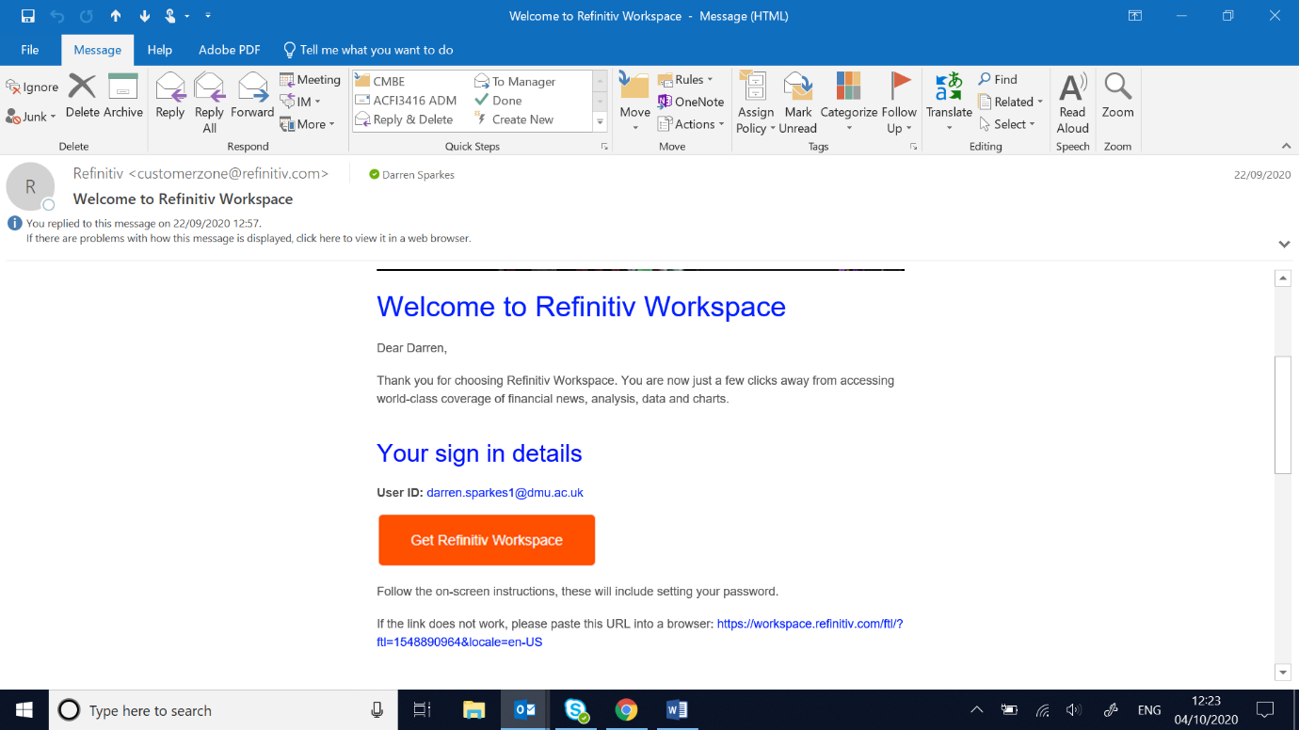

**Activity 2.**

You will be taken to Chrome to set up a password to use with your ID as in Fig. 2 below. Please ensure that you choose a password that you can remember and/or write it down somewhere (perhaps on your phone) so that you will be able to access Eikon in the future.

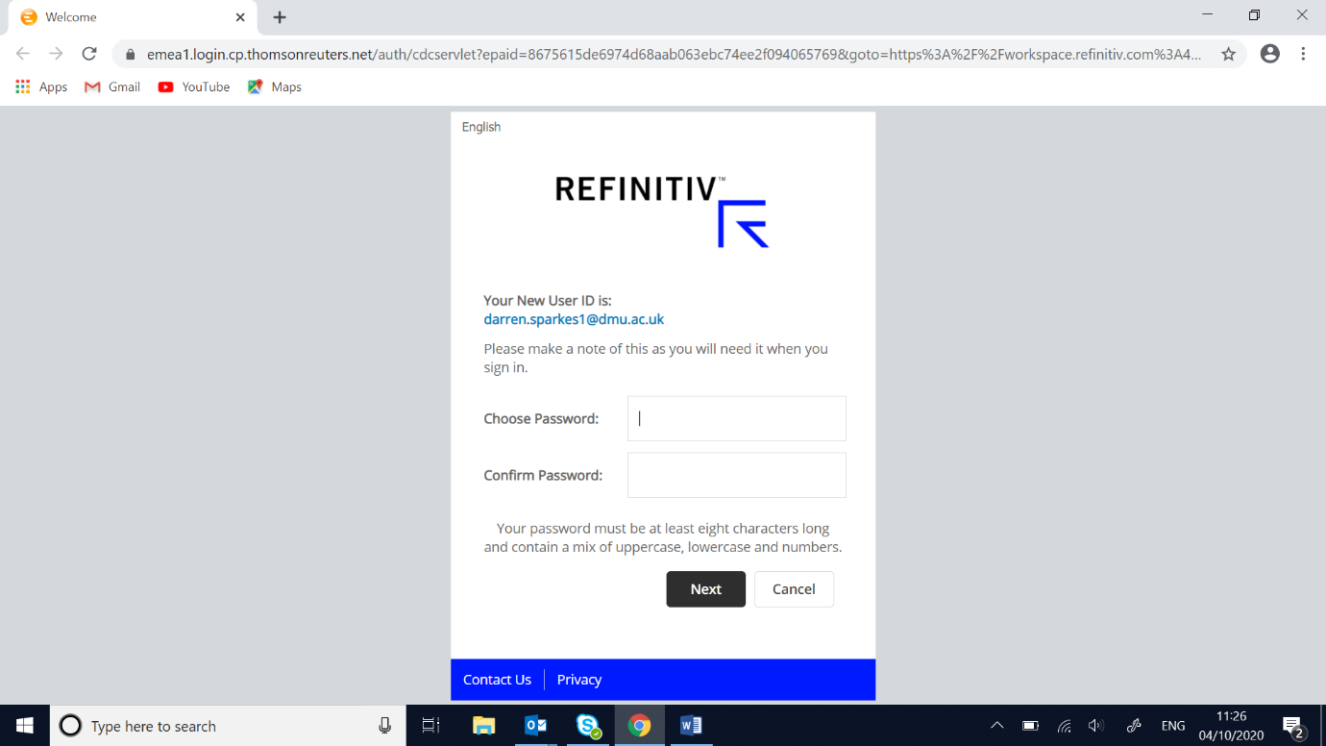Fig. 2

Please note password requirements.

**Activity 3.**

Fig. 3

Please note!

Select ‘Open in Web. You can have the option to download to your machine at a later time.

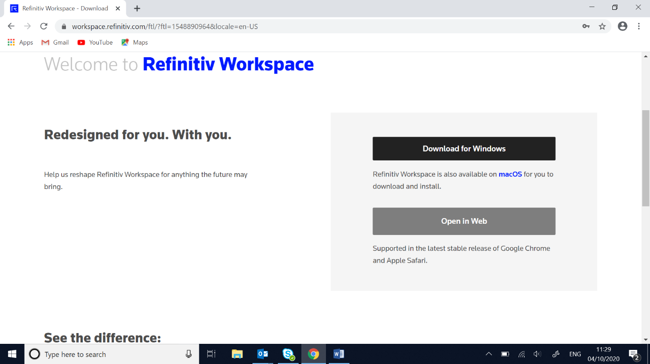

**Activity 4.**

Fig. 4

Read (your choice!) and accept the software Licence terms

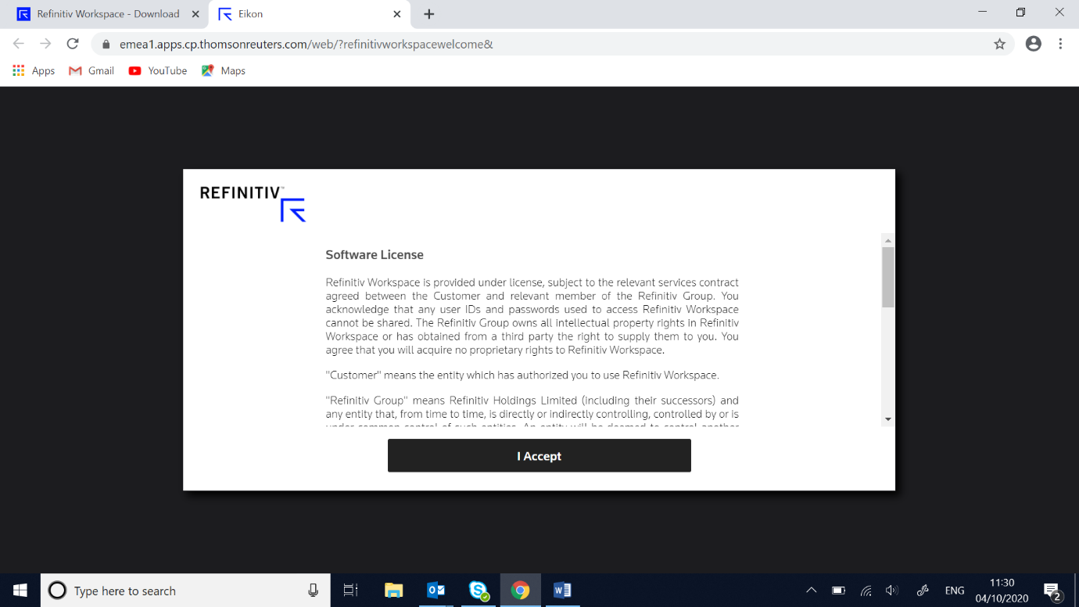

**Activity 5.**

Fig. 5

Select your role from the drop-down list. You must select ‘Student’ per Fig. 6 and click on the ‘Next’ button. Your profile will then be displayed as in Fig. 7. Then click ‘Confirm’.

Job Title is not needed

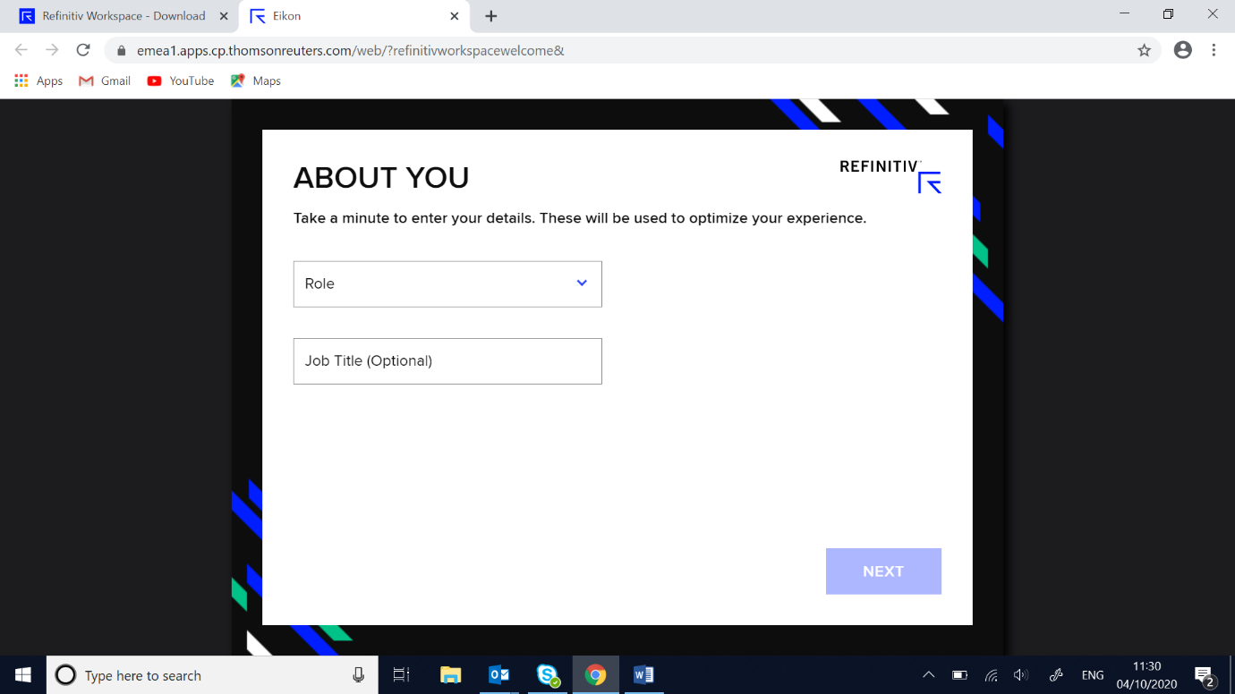

Fig. 6

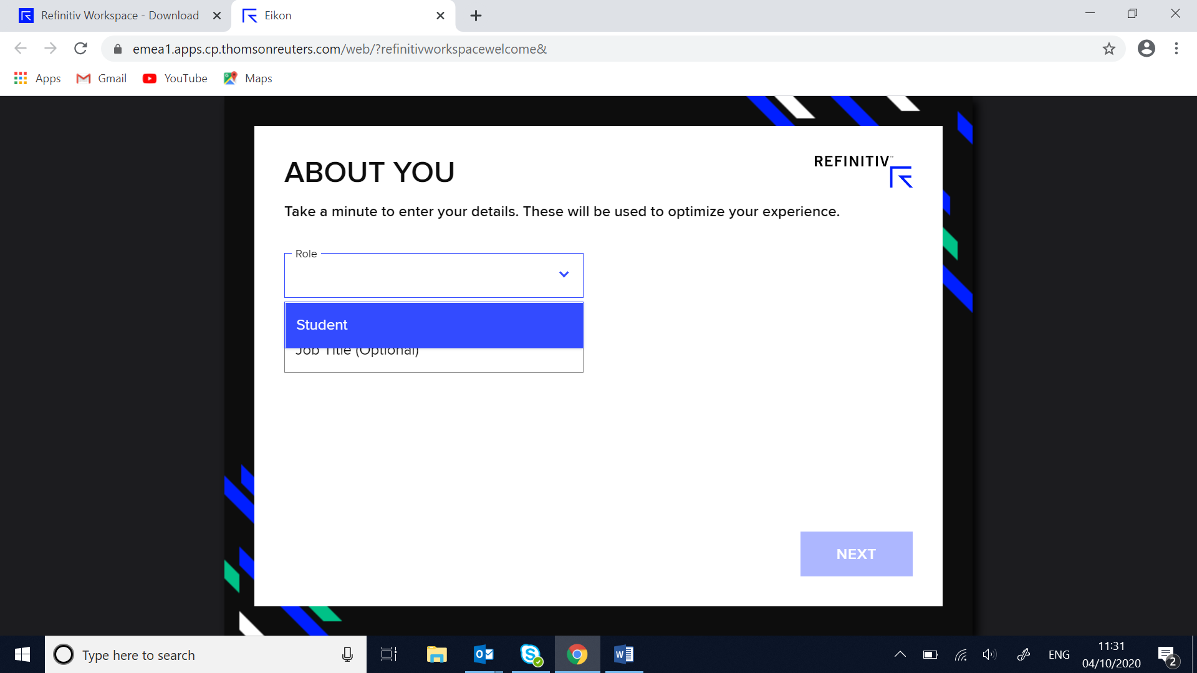

Fig. 7

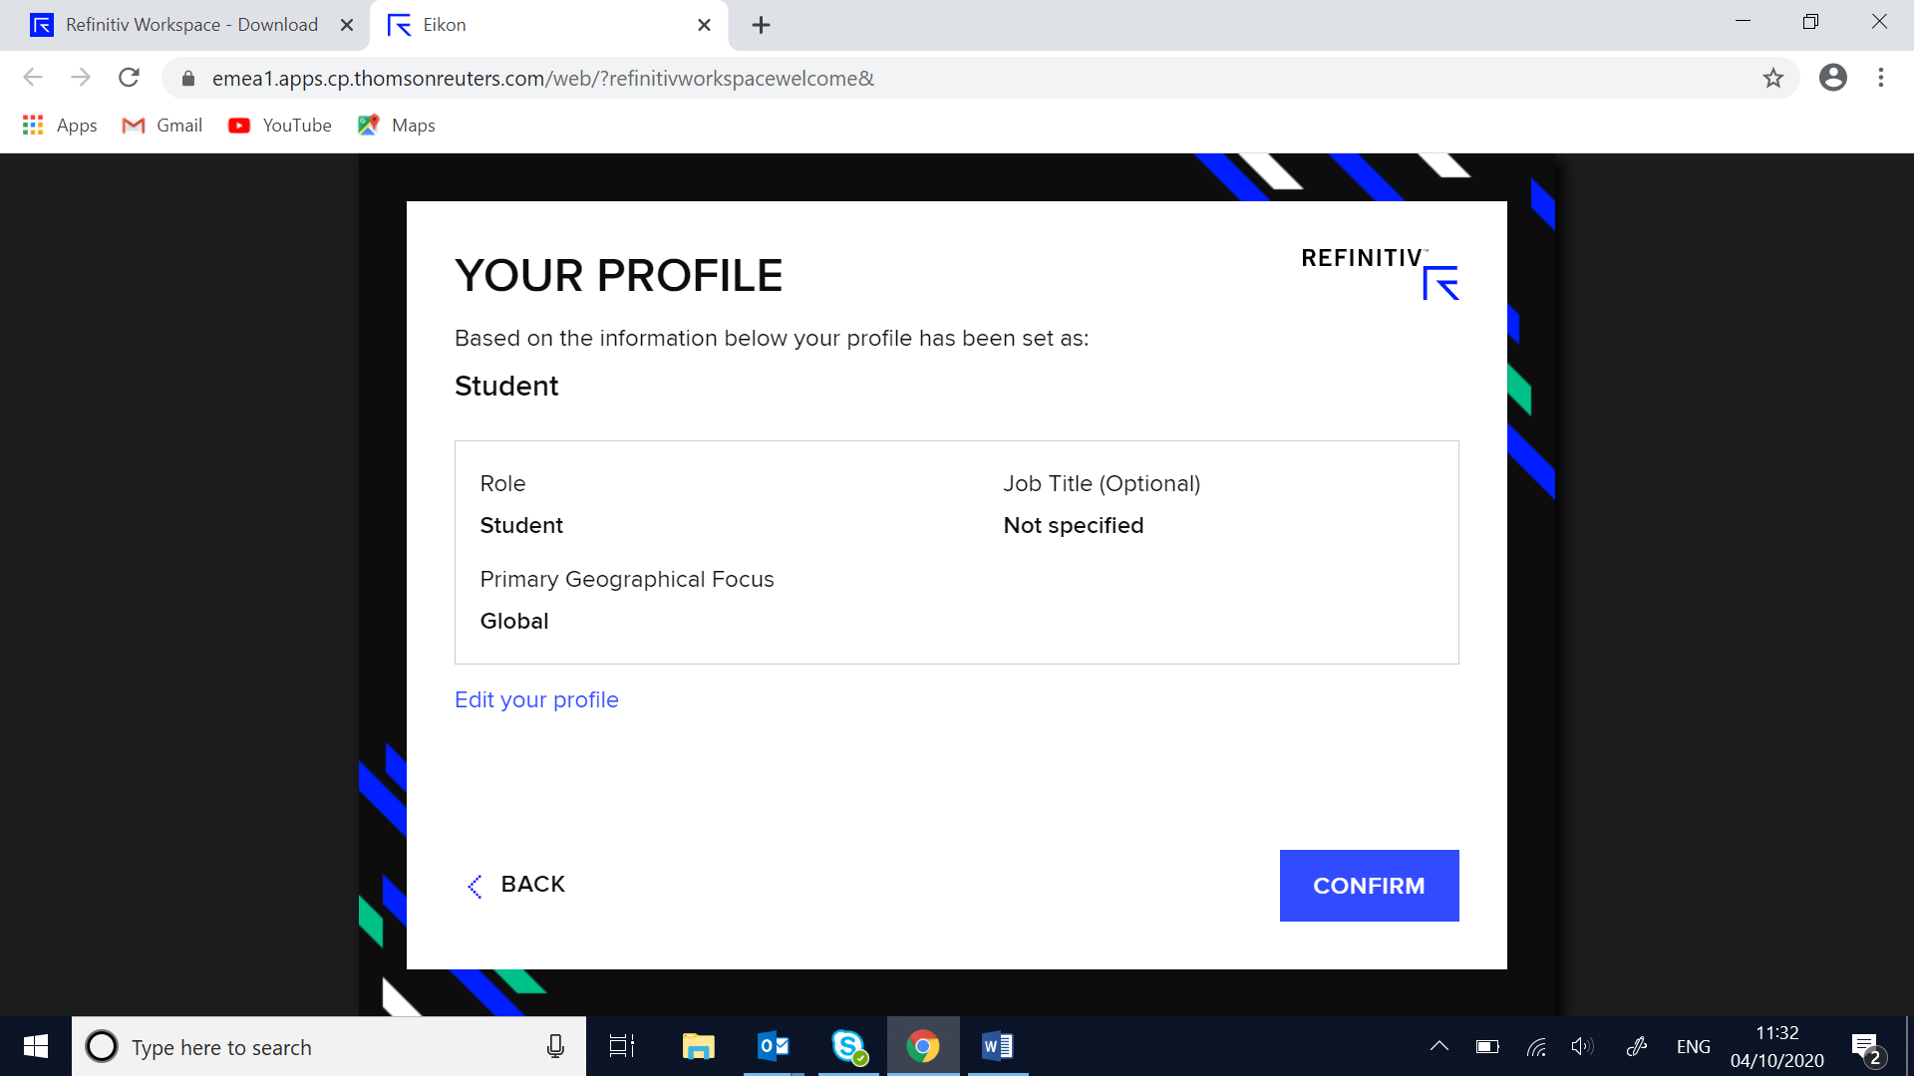

**Activity 6.**

Fig. 8

Work through the ‘Welcome’ features and then click on ‘Get Started’ (Fig. 9) or ‘Skip tour’.

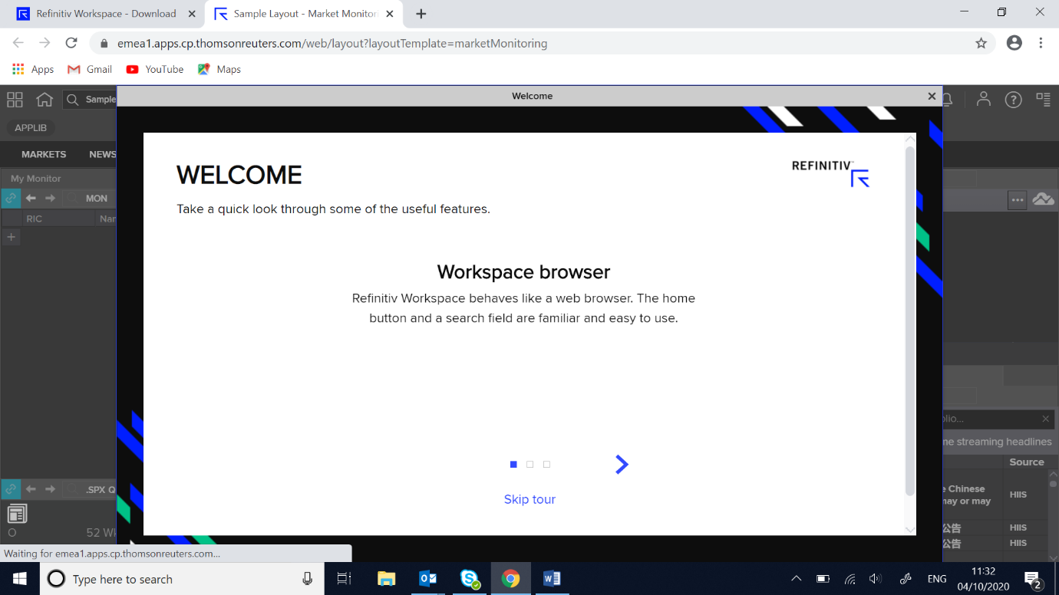

Fig. 9

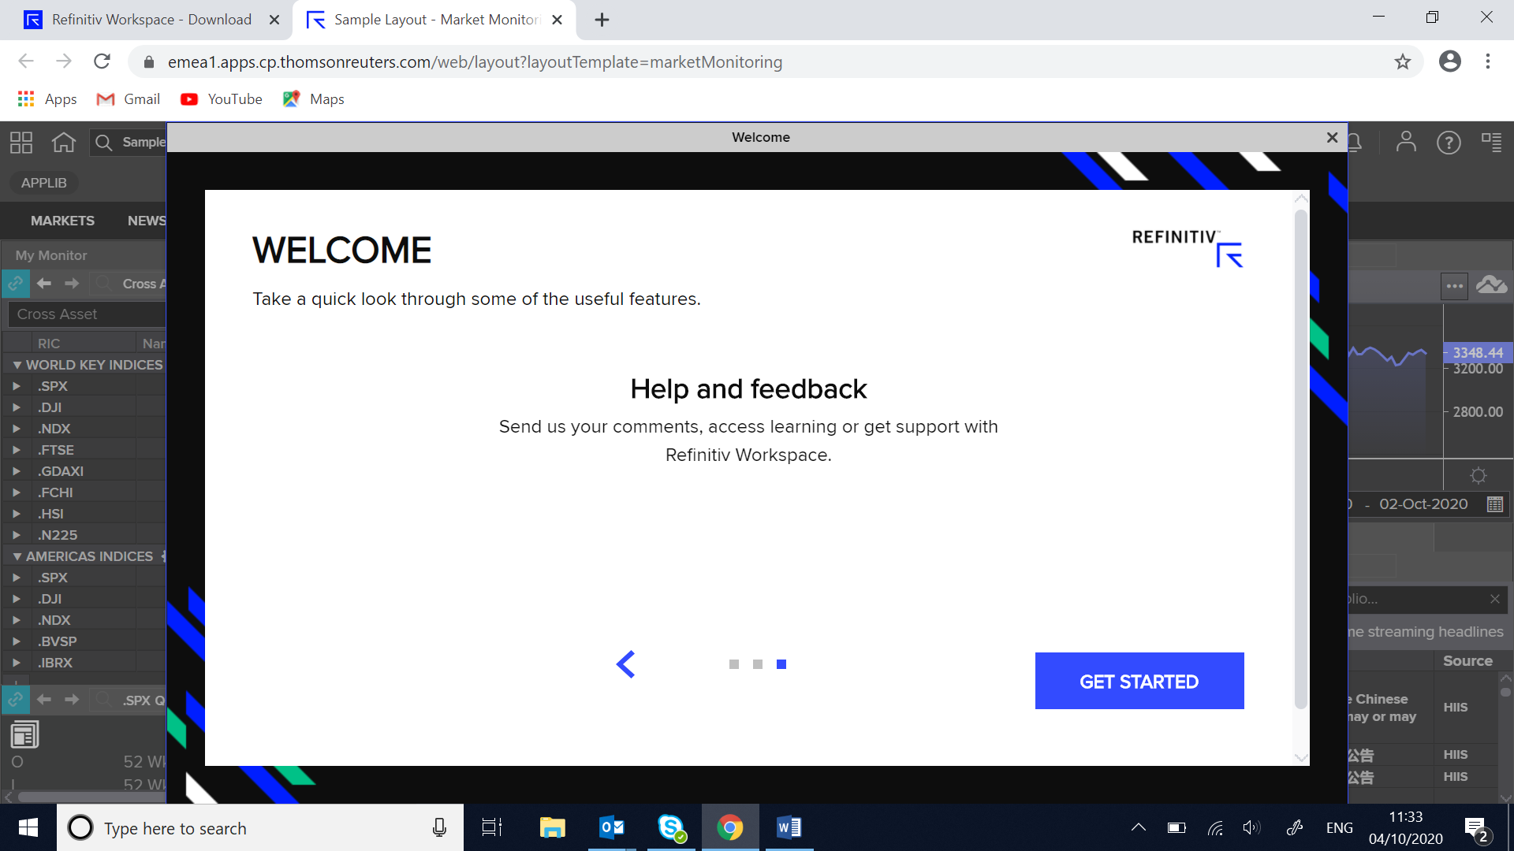

**Activity 7.**

You should be presented with your home screen as in Fig. 10. If your screen does not look exactly the same as Fig. 10, there is no need to worry. You will have the chance to set your homescreen to what you want in the future.

Fig. 10

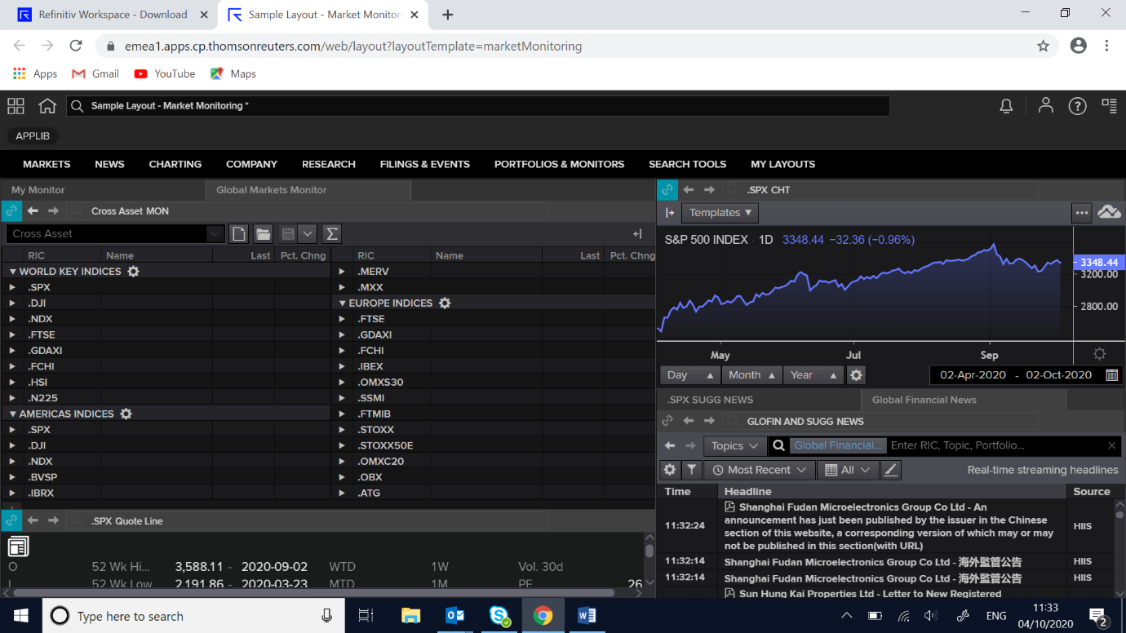

**Activity 8.**

Fig 11.

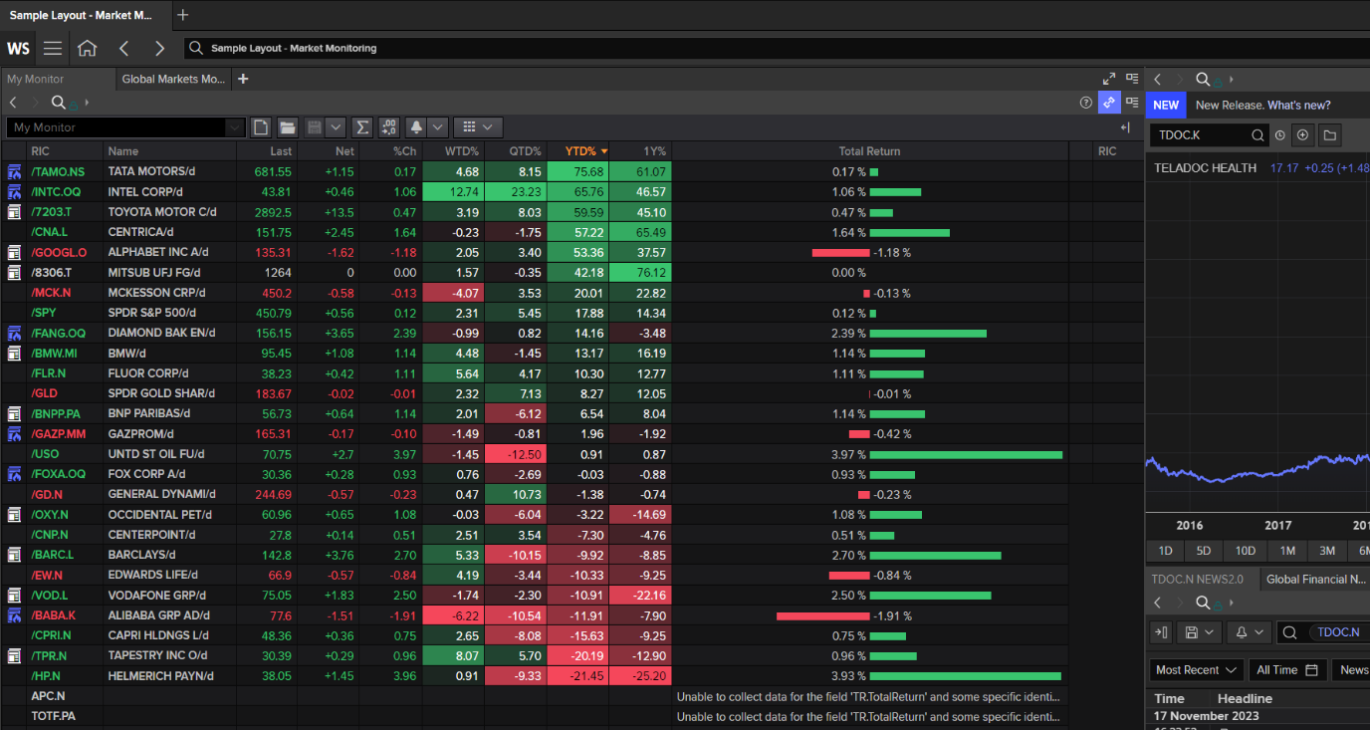

Go to the WS icon and select ‘Settings’.

Fig. 12 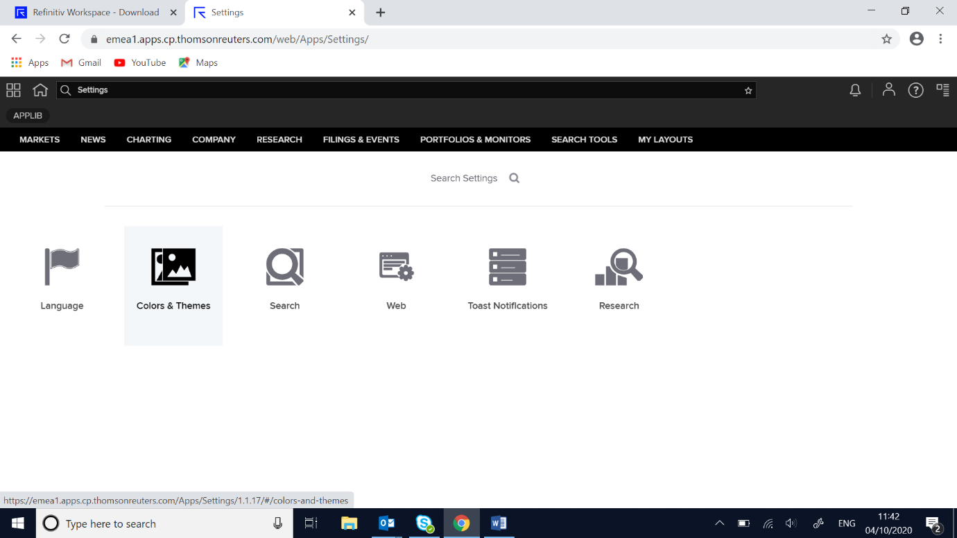

Select ‘Colors and Themes’ (apologies for the American spelling!)

Fig. 13

Select ‘American’ and click on ‘Apply’. This will change the colours used for the price of equities to the American style which I think we will be more familiar with:

Increasing prices in Green, Decreasing prices in Red, Non-movers in White.

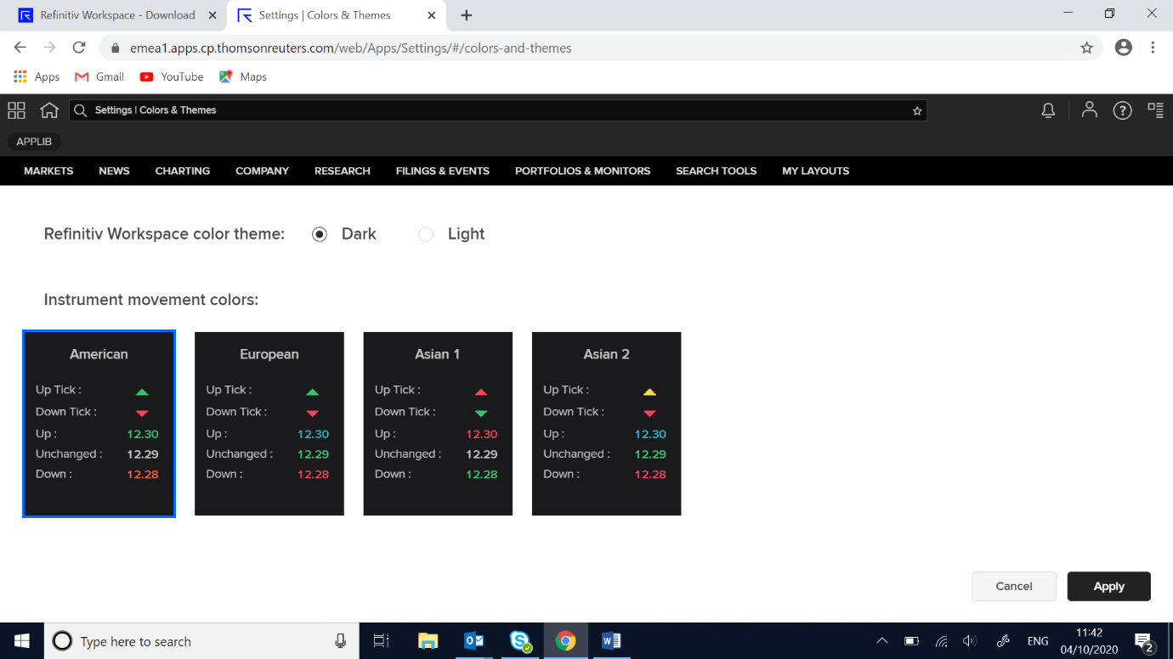

**Activity 9.**

Click on the ‘Home’ icon to return to your ‘Homescreen’ as shown in Fig. 15.

Fig. 14

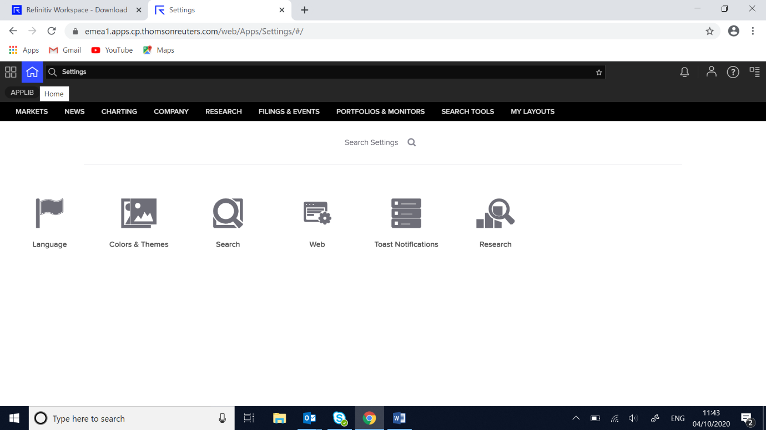

**Activity 10.**

Fig. 15

Click on the ‘?’ help button and select ‘Get Training’. This will take you into another browser screen as shown in Fig. 16.

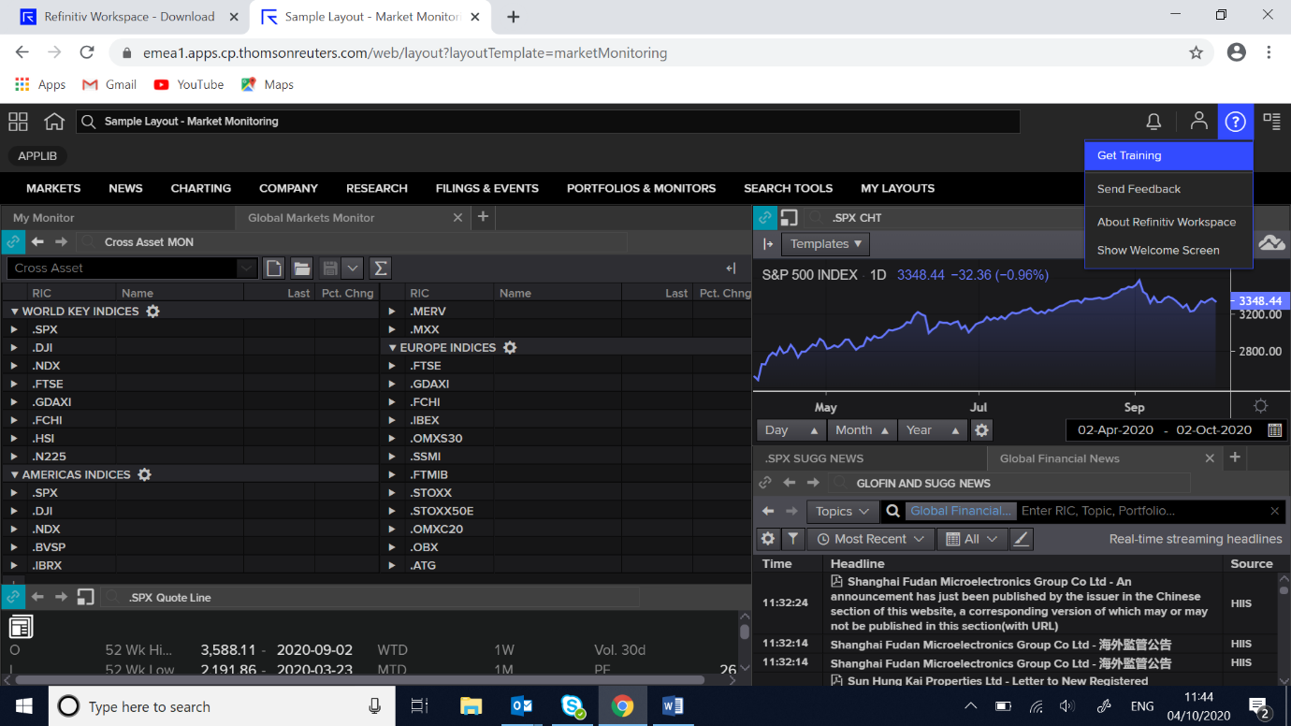

As sown in Fig. 16, Refinitiv have a series of training videos for you to watch that will cover how to use the Refinitiv software. Most of these are only a couple of minutes long. The first time that you click on a video you will be asked to sign in with your **DMU EMAIL ADDRESS**.

The training videos will enhance your ability to use the software and will, therefore, **directly impact upon your ability to manage your presentation assignment and final examination**. However, I recommend that once you have signed in, you go to Activity 11 to view the videos as part of the user ‘Certification’ process rather than doing them as a standalone exercise.

Fig. 16

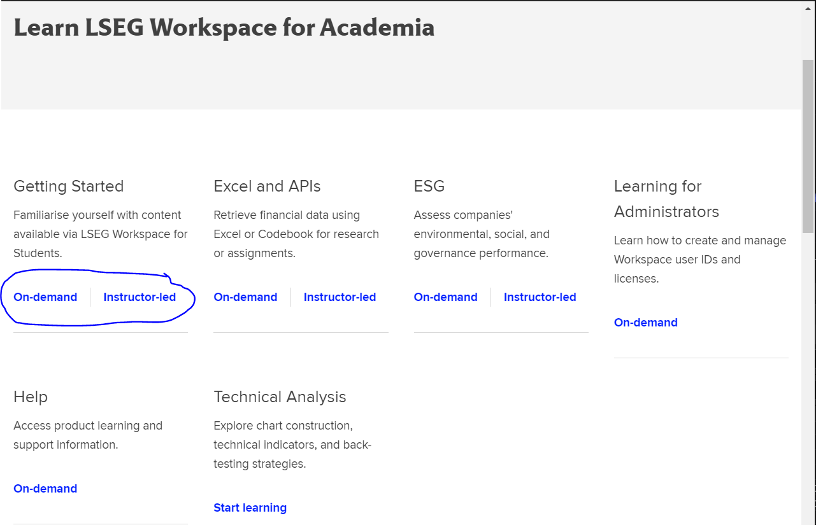

Click here, and complete the course

**Activity 11.**

Refinitiv also has a user ‘Certification’ qualification. This can be accessed from the menu bar as shown in Fig.18.

Fig. 18

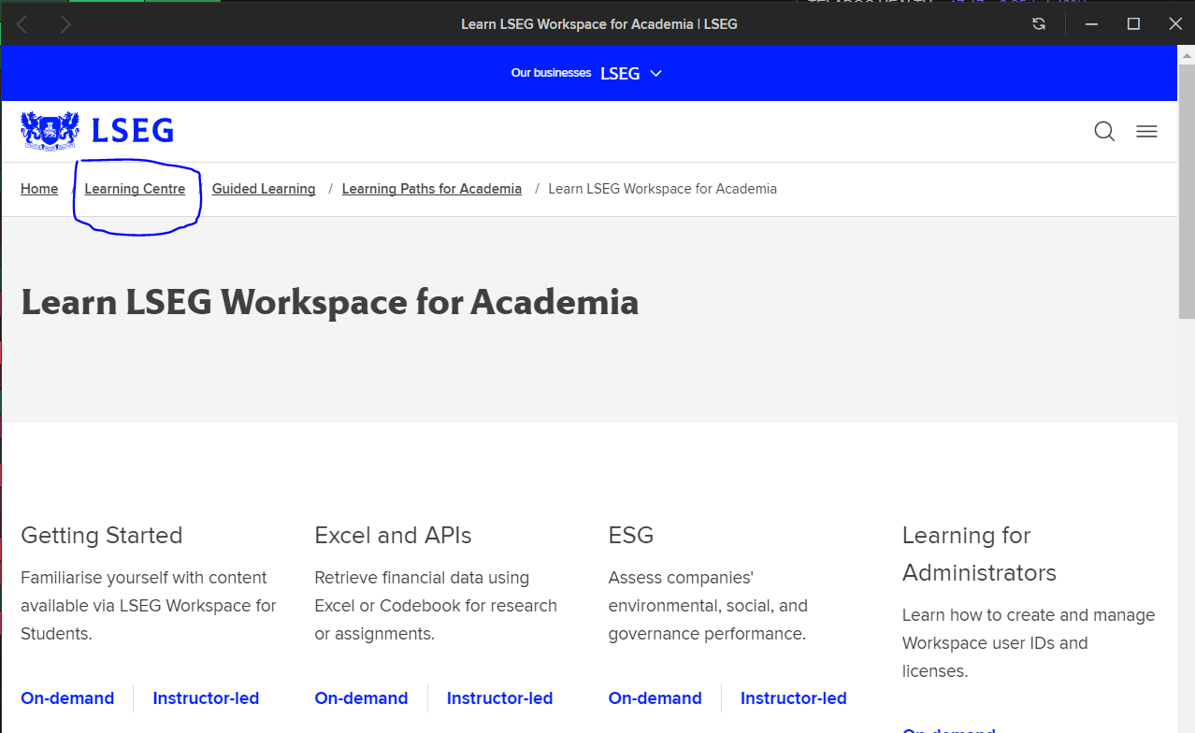

Click here

Fig. 19

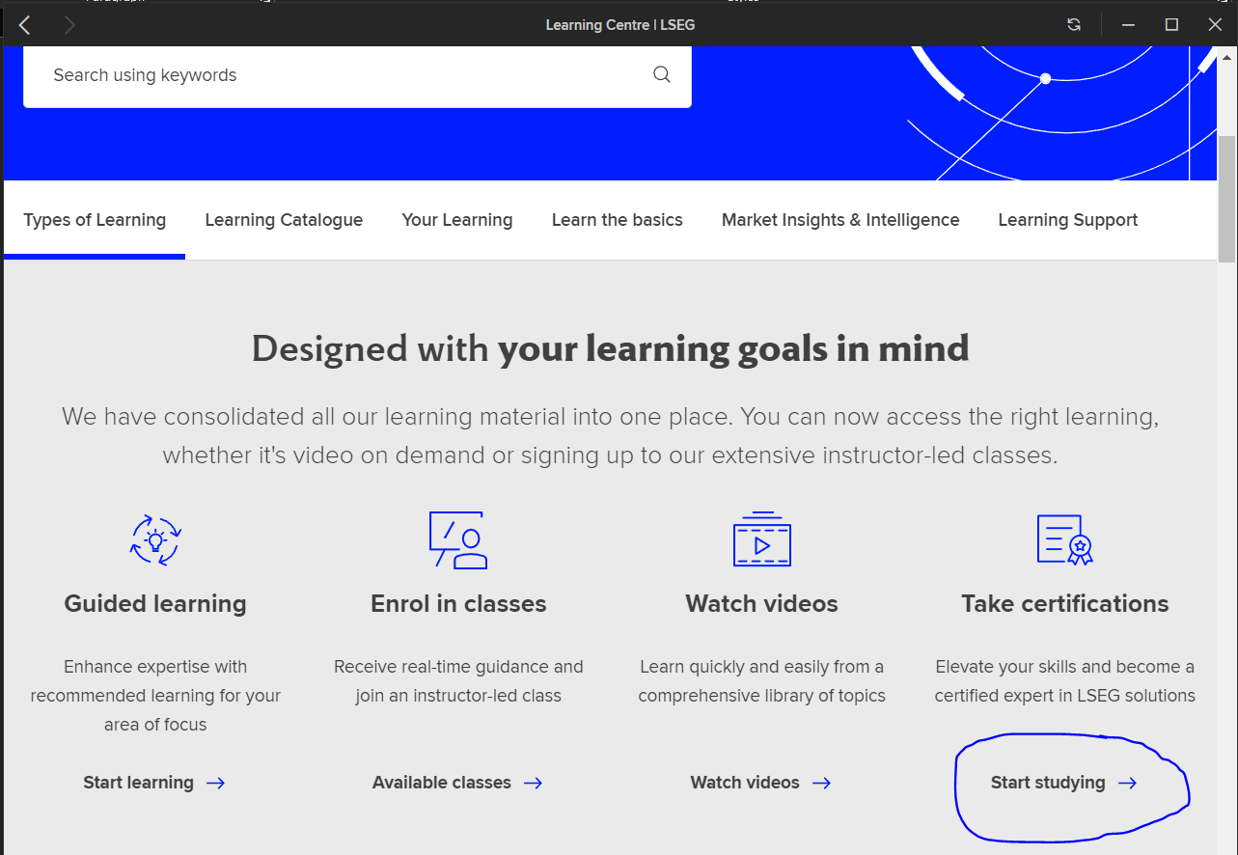

Click here, and complete the LSEG Workspace certification

The ‘Certification’ screen, as shown in Fig.19, gives details on how to complete the certificate. In brief, to obtain certification status, you must complete training videos and e-learning modules and then pass a 60-minute test including 30 multiple-choice questions. You will need to select the Eikon Product Certification (Fig 19.) and this will take you to the required Learning Materials.

Students must begin to complete the Refinitiv Workspace certification during the lab. Not only will this help students for their assessment, but it will also **enhance their CVs for presentation to potential employers**.

Fig.19

**Activity 12.**

Continue to work through the Refinitv Eikon training materials and explore the software as part of your self-study. The quicker you become familiar with using the software, the easier you will find our labs throughout the academic year.

**Activity 13.**

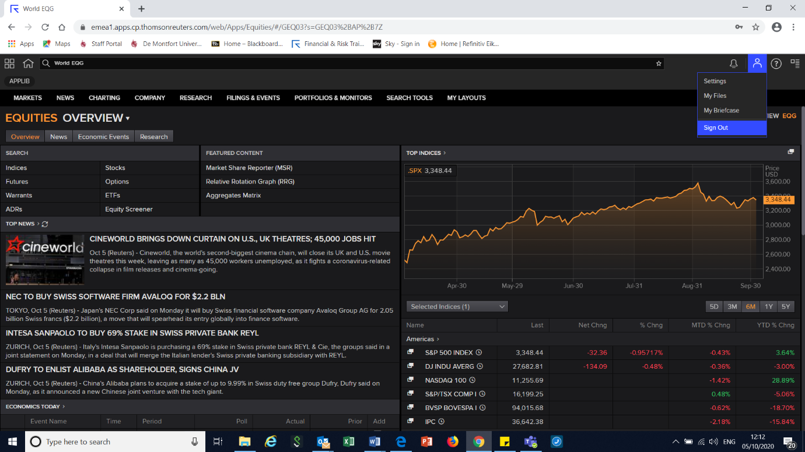Fig. 21

To sign out click on profile icon and select ‘Sign Out’.

**Workshop – Terminal Access to Bloomberg**

This is an OPTIONAL material; students can download the lab for Access to Bloomberg Terminals access in bb, folder ‘LABs’ Handbook’. The lab can also be downloaded from the shared folder for on [this link](https://demontfortuniversity-my.sharepoint.com/:b:/g/personal/ccalde00_dmu_ac_uk/ETAD2O0XDJtLqv_obbkZ9rsBXE3XQp27ufB_VZOOdizkQw?e=88hRQy).

Lab 6 – Refinitiv :News, forecasts, Macrox

Open the user manual on bb, module site, find the folder ‘Labs’. Students must cover pages 9 to 13; “Setting up Thomson Reuters Eikon”.

# Activity 1 – Read the news for the UK.

In the search box, type ‘TOPNEWS’ and also ‘TOPNWS’. Within ‘TOPNEWS’, discuss the news you are following with your colleagues and review’ trending topics’. Explore further the labels of this app. Search ‘IFR Markets’ in google; what it is? Click under the label ‘Markets’ and click on IFR and review the ‘Refinitiv NEWSCASTS’ for interesting international financing review briefings. Finally, create your own new Refinitiv Digest.

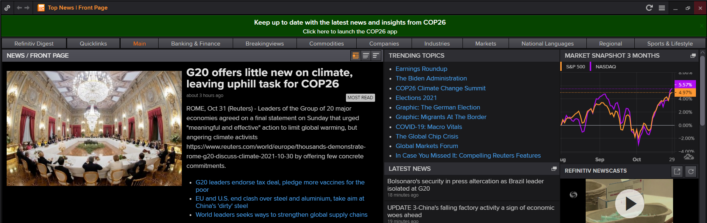

# Activity 2 – Find upcoming forecasts for the upcoming and highly important US economic events for w/c 1 Nov.

Explore economic news from specific groups of markets or countries. Use the Economic Monitor by typing ‘EM’. Apply filters to perform this activity.

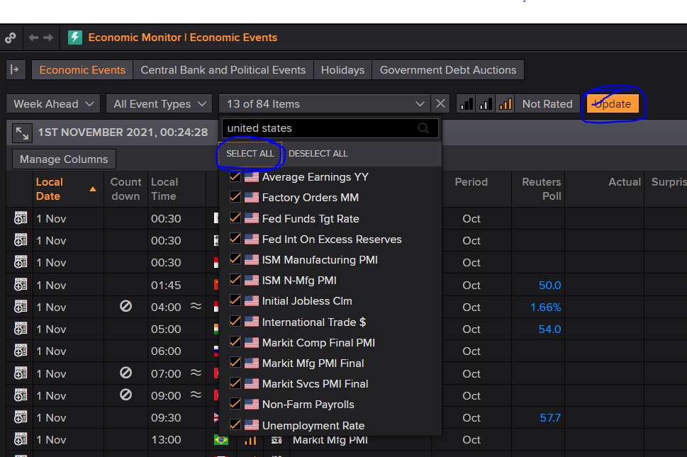

# Activity 3 – Discuss with your peers: in what country would you invest your savings today?

Explore the Economics Application’ EC’. Investors usually use this top-down approach to choose whether to invest in a specific market. In what country would you invest your savings?

# Activity 4 – Interesting shares to invest

The application ‘MACROX’ provides outstanding visual elements. In the tab ‘REGION’ and ‘countries and regions in Universe’ choose Europe; then go to the tab ‘SECTOR’ and select ‘Internet and Catalog Retail’; afterwards, click on the tab ‘SECURITY’ and sort the companies by ‘COMPANY MARKET CAP (USD)’. Browse for some attractive shares to invest in.

# Activity 5 – Are we going to get negative interest rates in the UK? I thought so one year ago; however, after recent developments in the supply side, it would look more appropriate a hawkish stance. Are we going to get higher interest rates next year in the UK?

* Review forecasts of Centrals Bank’s interest rates. Use the application Central Bank Poll ’CBP.’
* ‘US FED INTEREST’ provides more detailed information relevant to Central Banks.

